**Group 17 – Interaction and High Level Design**

Authors: Alexander Webb (ajw21), Frederick Kranich (frk2), George Vinters (ghv), Grigor Mironov (gmm11), Peter George (peg4), Jose Iznardo (jov2), Jack Thomson (jat36)

Date: 26/10/2015

Version: 1.2

Status: Released

Department of Computer Science

Aberystwyth University

Aberystwyth

Ceredigion

SY23 3DB

Copyright © Aberystwyth University

Contents

1 Introduction 3

1.1 Purpose of this Document 3

1.2 Scope 3

1.3 Objectives 3

2 Deployment Description 3

2.1 Applications in the System 3

2.2 Application Interaction 3

2.2.1 TaskerMAN 3

2.2.2 TaskerCLI 4

3 Interaction Design 5

3.1 Use-cases 5

3.2 User Interface Design 6

3.2.1 TaskerMAN 6

3.2.2 TaskerCLI 6

4 Component Description 6

5 Significant Classes 6

5.1 Interface Description 6

6 Detailed Design 6

6.1 Sequence Diagrams 6

6.2 State Diagrams 6

6.3 Activity Diagrams 6

6.4 Significant Data Structures 6

7 Appendix 7

7.1 Appendix A 7

7.2 Appendix B 31

8 References 35

9 Document History 36

# 1 Introduction

## 1.1 Purpose of this Document

The purpose of this document is to detail the design of the final system.

## 1.2 Scope

The document will detail the applications that the system contain along with details of the interaction. The document should include useful design information such as the user interface designs and the UML diagrams of the system. This document should conform to standards laid out in SE.QA.05A [1].

## 1.3 Objectives

The objectives of this document are as follows:

* Clearly lay out the design of the program.
* Allow the development team to be able to create a full program from the information in this specification.
* Allow the team to be able to understand the system in terms of what the system comprises of and how they interact.

# 2 Deployment Description

## 2.1 Applications in the System

The primary database being used will by MySQL, inside of this, the database will be manipulated using the SQL query language in order to access data and manipulate it. This includes add. Update and delete functionality.

The web application has been designed to work on: Internet Explorer, Mozilla Firefox, Google Chrome. These three browsers are most commonly used and are therefore targets for functionality in the application.

Primary application language will be Java, written in the eclipse IDE as a standard for the project.

The system will be designed to run on: Windows, Mac and Unix systems. This covers all major operating systems including most distributions of the Linux operating systems. This ensures that the majority of people will be able to use the application as required.

When installing the application onto a user machine, a CD will be used to install the application. This makes it possible to install the application using physical media in order to deliver the application.

When communicating with the databases, the web client will be using PHP as its primary server side language in order to send and receive requests to and from the databases.

## 2.2 Application Interaction

### 2.2.1 TaskerMAN

The nature of the interaction between the web client and the database is based around the interaction between three components of the overall system; the users’ personal computer, the web client onto which TaskerMAN is hosted, and the database (which for the purposes of this description will be described as being hosted in the university system). The User PC platform will need to have a modern web browser and an internet connection in order to access the Database proper, although the user will have access to a “compatibility mode” which saves changes and progress on local storage. These will be uploaded to the database the next time the user runs TaskerCLI with an internet connection.

The web server is the application which hosts TaskerMAN, namely the HTML, CSS and PHP which are used to build it. PHP will be the language used for the clients’ interaction with the database. The site will be designed for use by administrators and managers, thus they’ll be able to create tasks, vie all tasks with their allocated team member(s), filter specific tasks by their name, status and member allocated, allocate them to specific team members, reallocate existing tasks to different members, mark tasks as abandoned. Authorizing certain user to utilize all TaskerMAN facilities is an optional feature for the development team to implement.

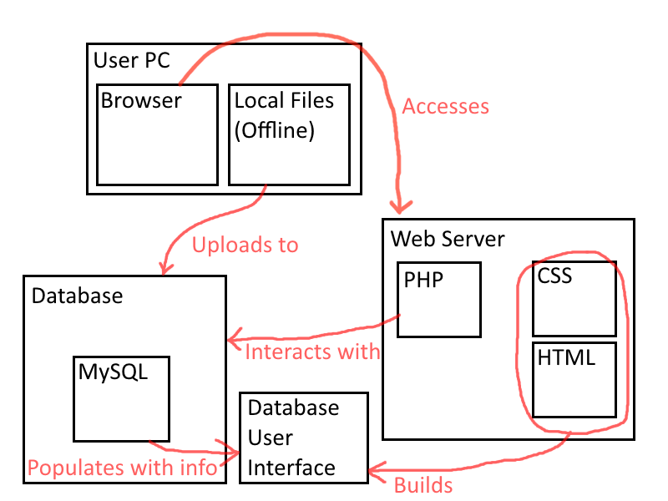

### 2.2.2 TaskerCLI

To make a connection between Java and a database we need to create DAO (Data Access Objects) for each table we want to access. There will be a class called 'database' in order to hold all the DAO, and Connection objects (objects that hold the connection between our code and the server). Each DAO needs to be extended from an abstract class called DAO which holds the reference instance of the database object and the reference instance of the Connection. We also need to create a few classes extending the abstract DAO class.

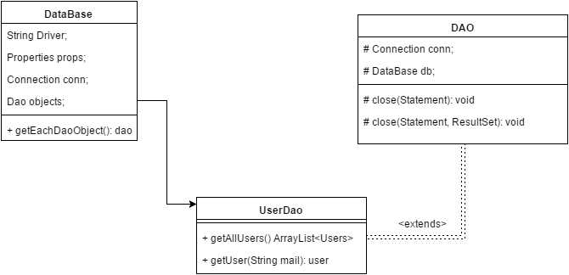

The database class has getters for each DAO we have. The abstract DAO class has methods for closing the statement instance and the resulting instance (these objects are required for retrieval of information from the database). Each DAO needs to have all the required methods with its appropriate SQL statements for information retrieval. This UML diagram has not been completed as the database has not been created yet, so the amount of tables and fields we have is unknown. This is an abstract idea for the purposes of design.

To create a connection we need a JBDC driver for each database type. In our case we use MySQL, so we use the MySQL driver for our connection.

# 3 Interaction Design

## 3.1 Use-cases

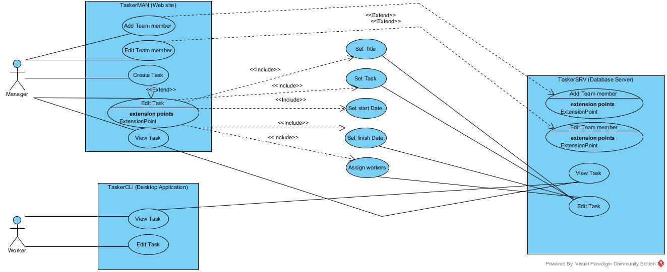

## 3.2 User Interface Design

The following designs for the web and desktop applications will be subject to change. The designs do not completely represent the final system.

### 3.2.1 TaskerMAN

The design for TaskerMAN is located in appendix A.

### 3.2.2 TaskerCLI

The design for TaskerCLI is located in appendix b.

# 4 Component Description

# 5 Significant Classes

## 5.1 Interface Description

# 6 Detailed Design

## 6.1 Sequence Diagrams

## 6.2 State Diagrams

## 6.3 Activity Diagrams

## 6.4 Significant Data Structures

# 7 Appendix

## 7.1 Appendix A

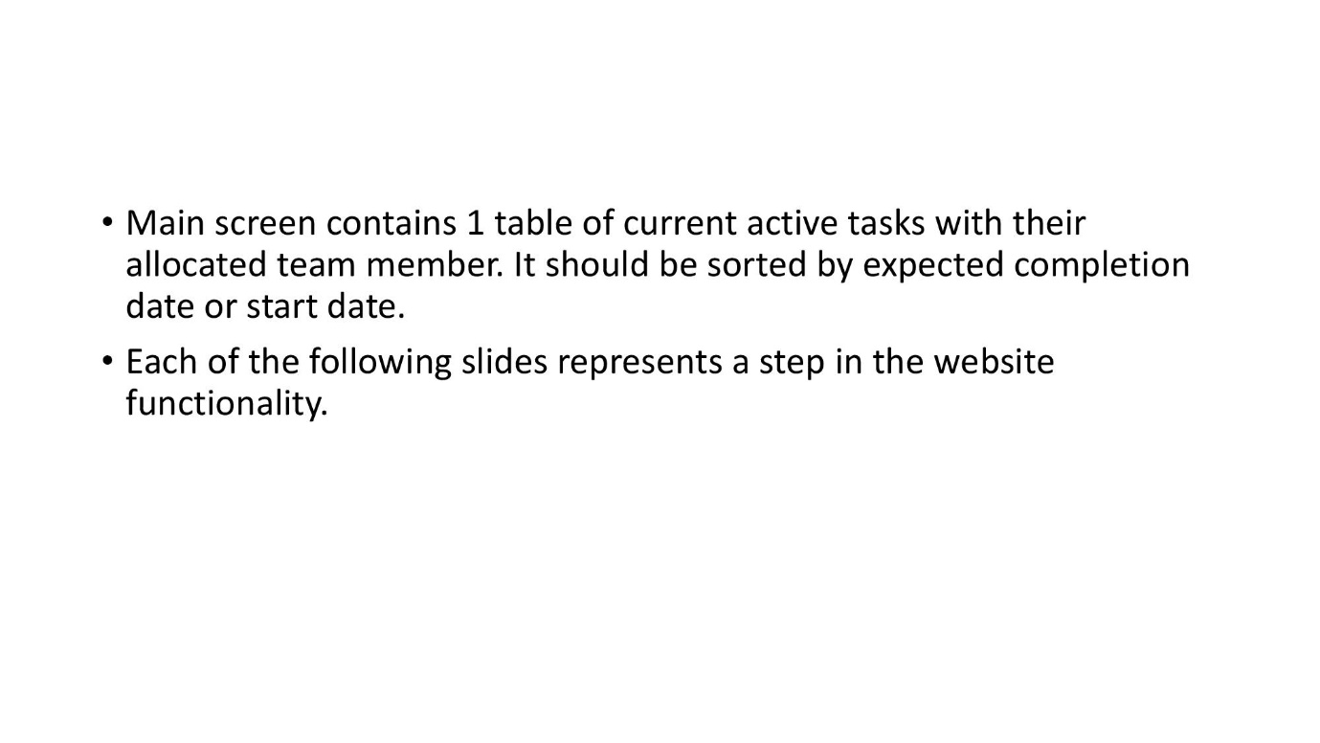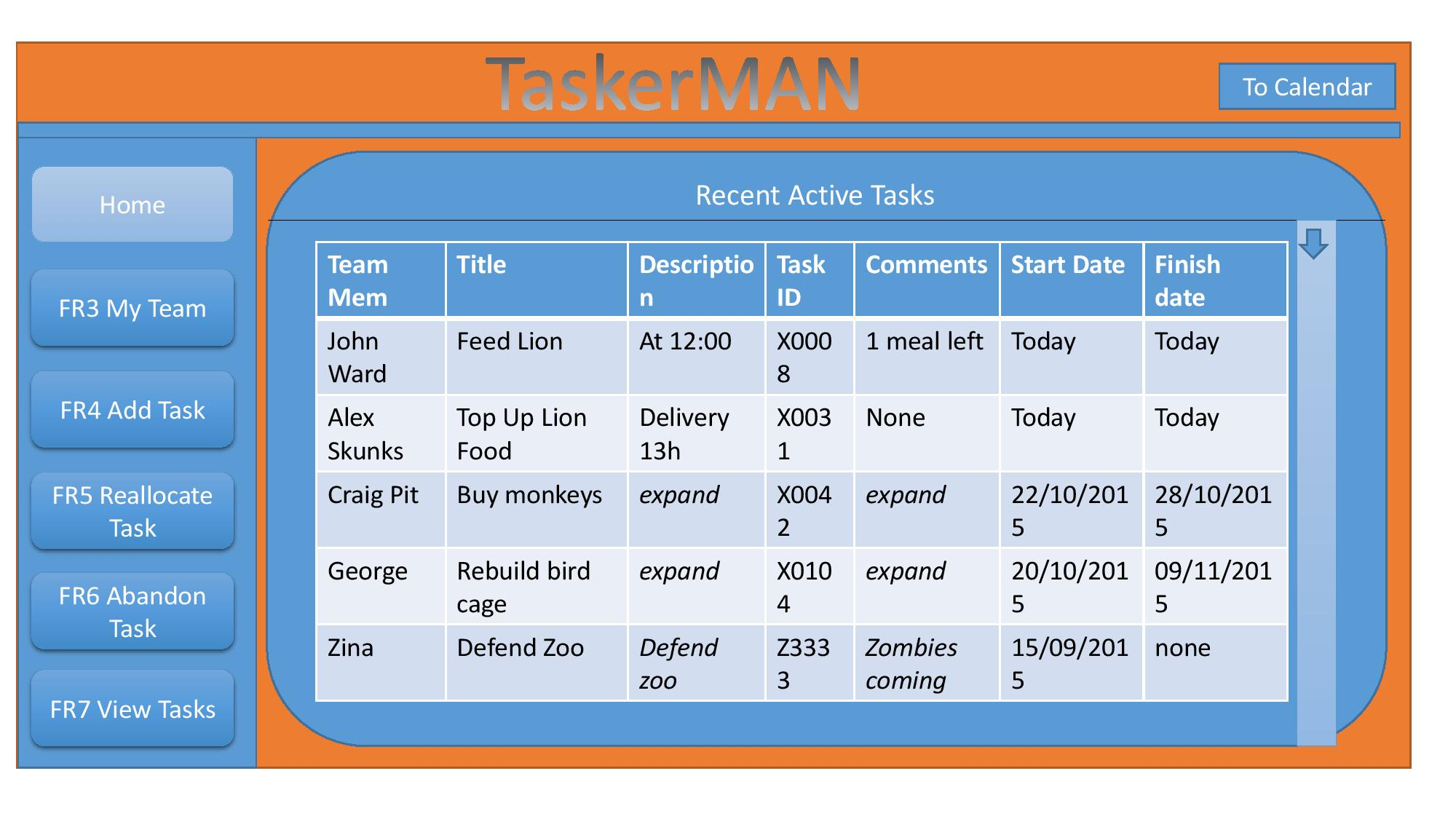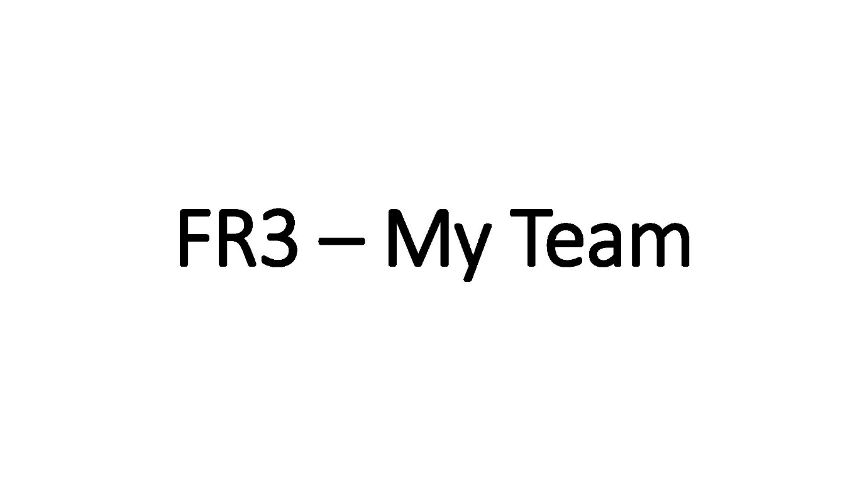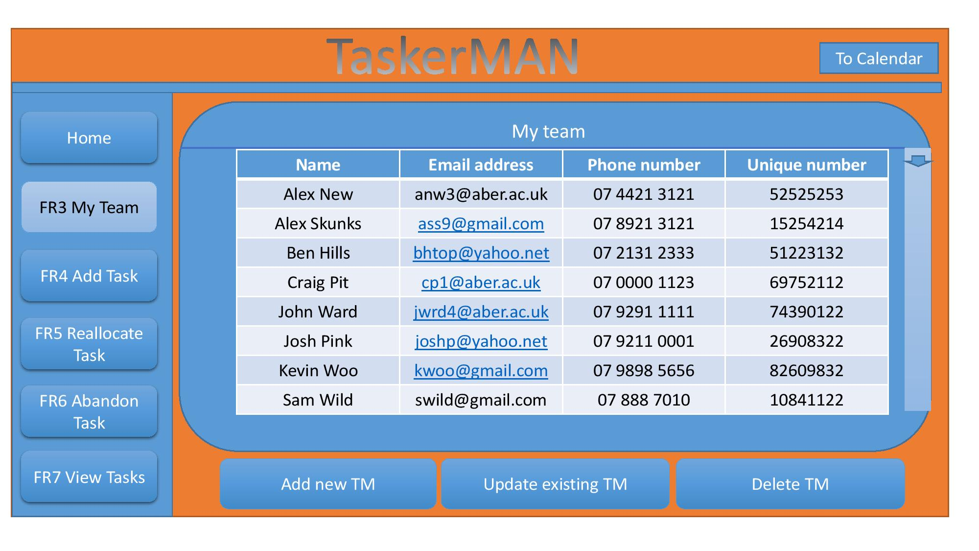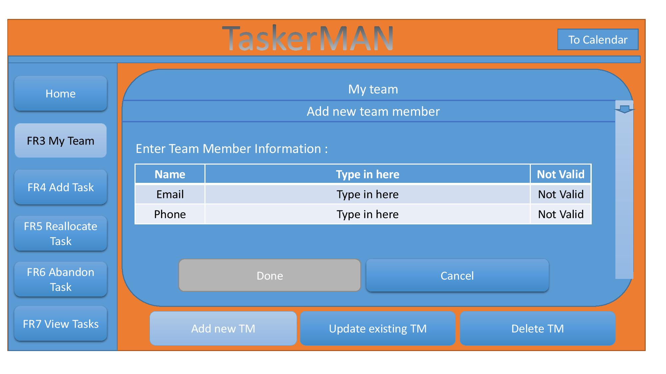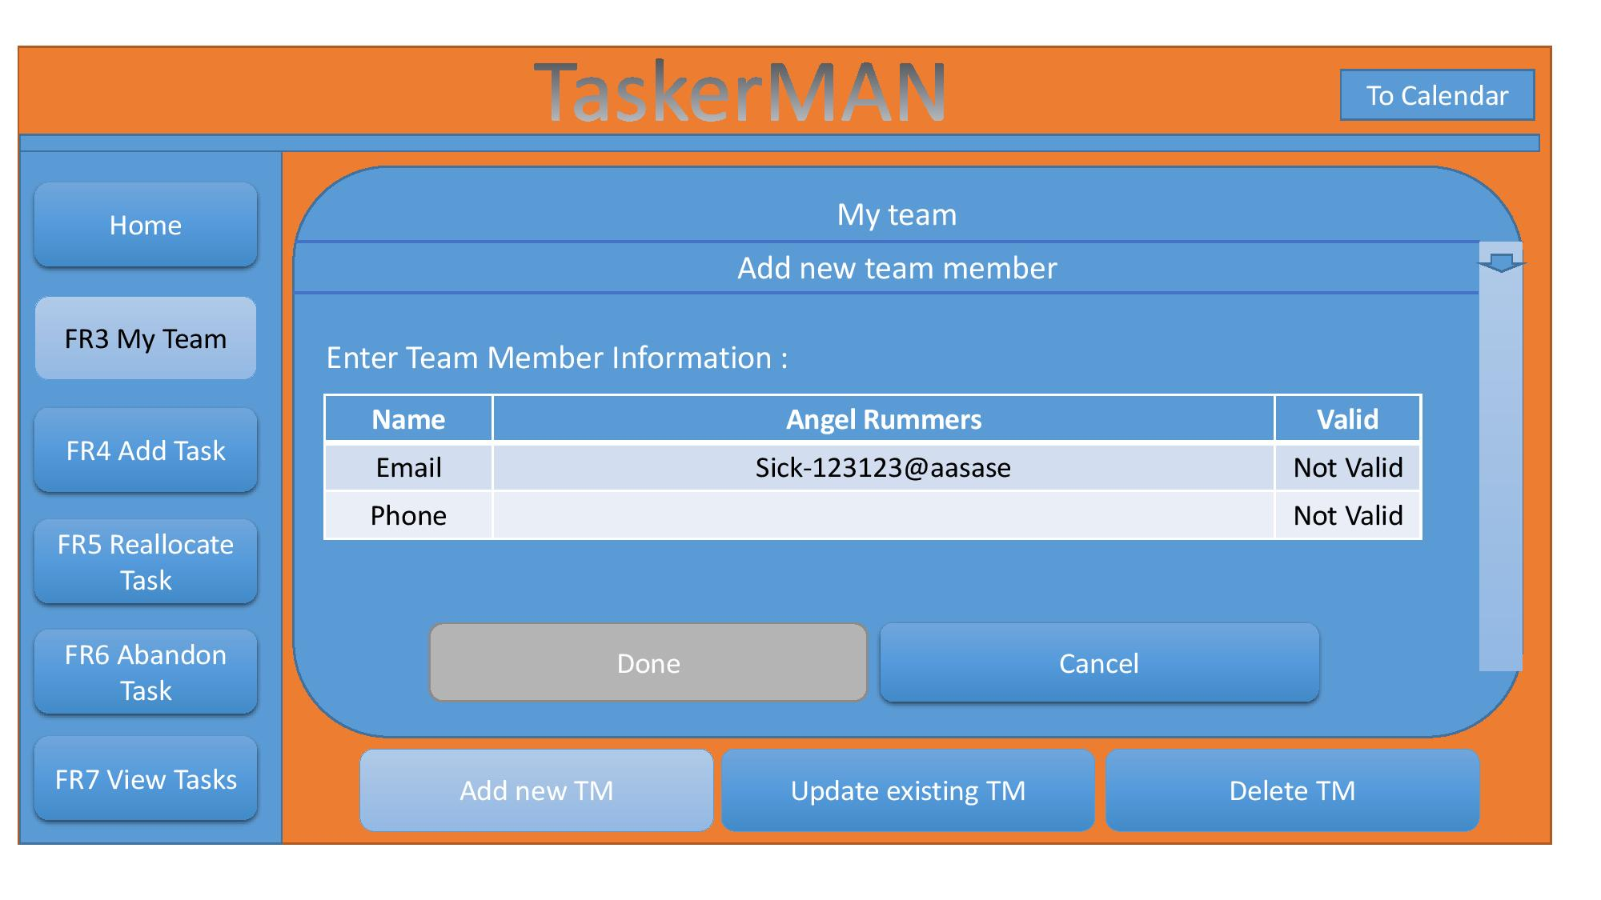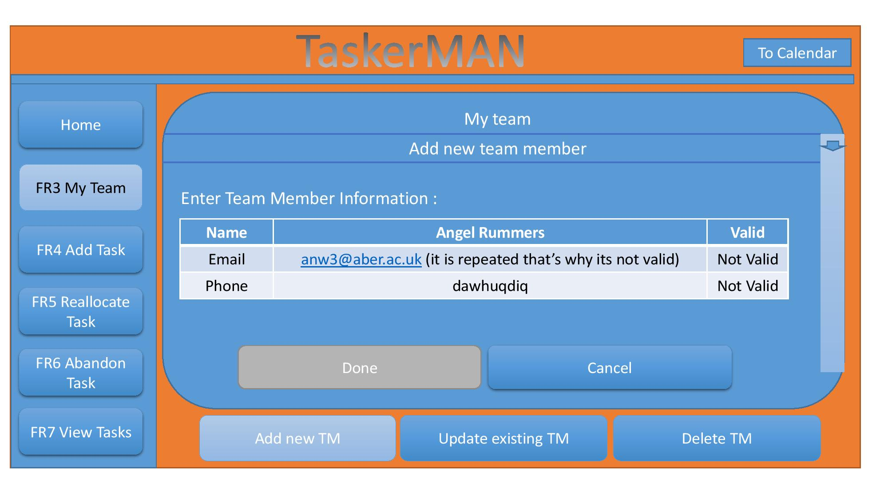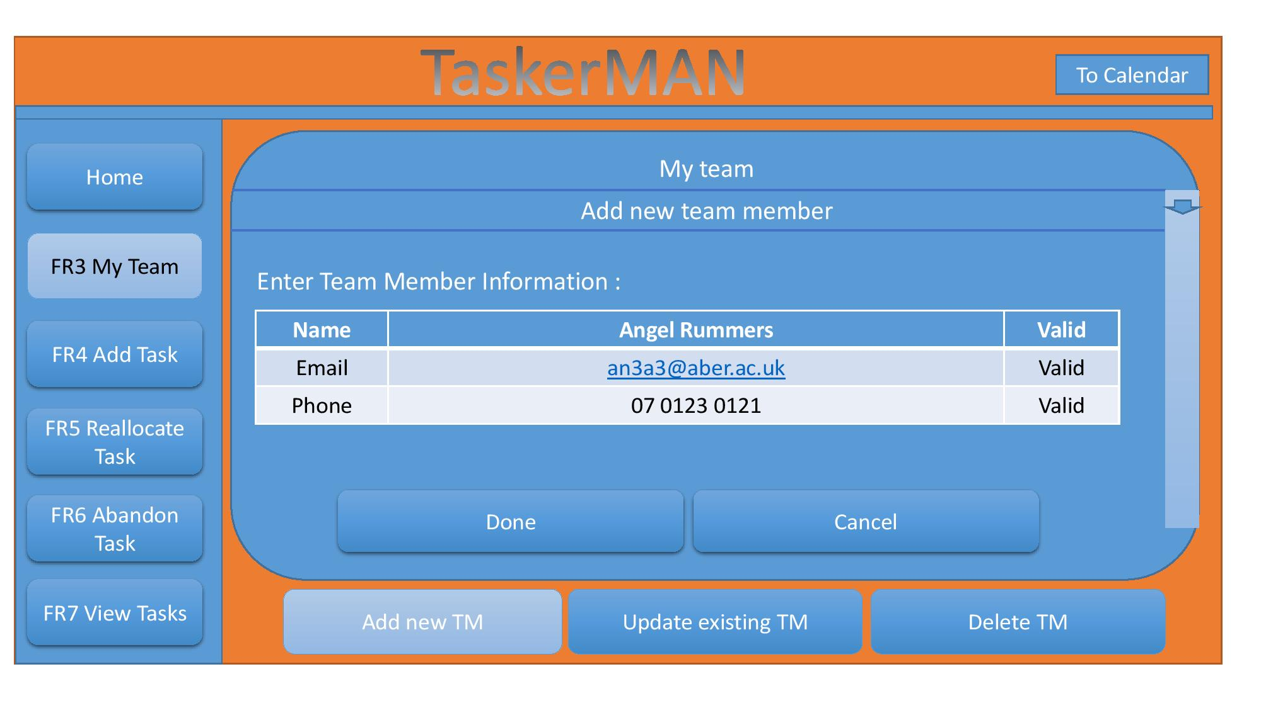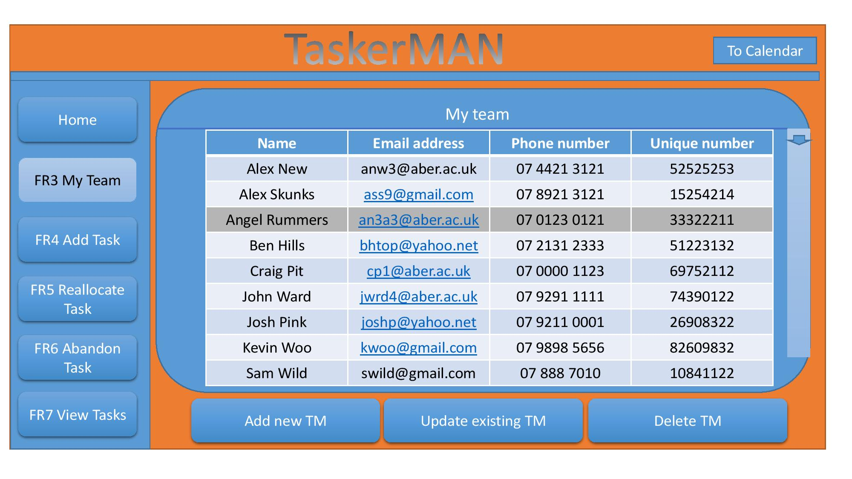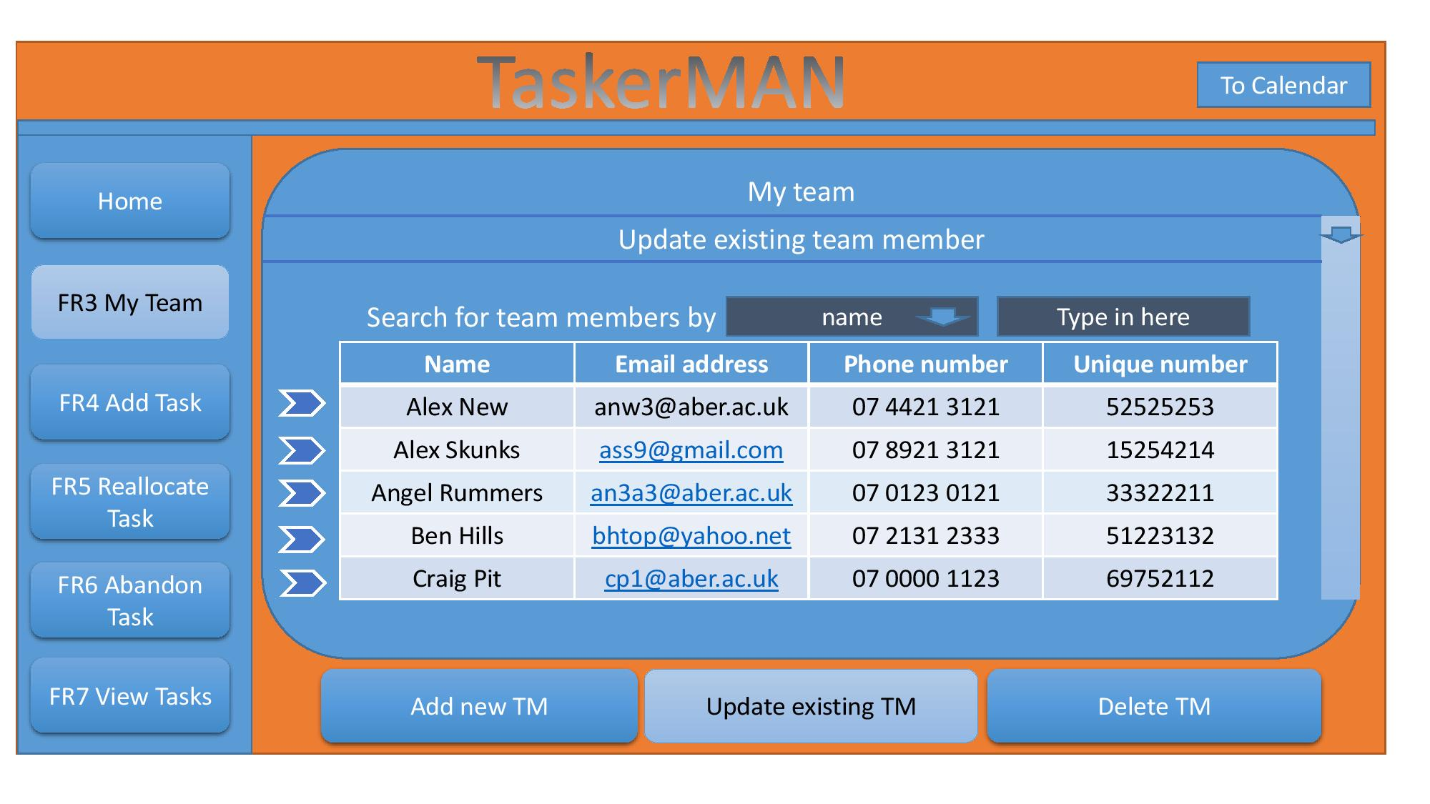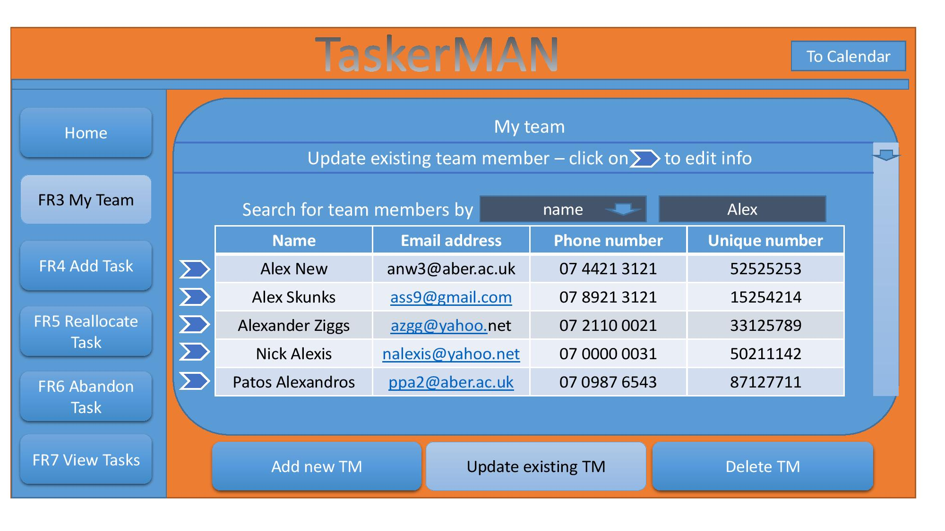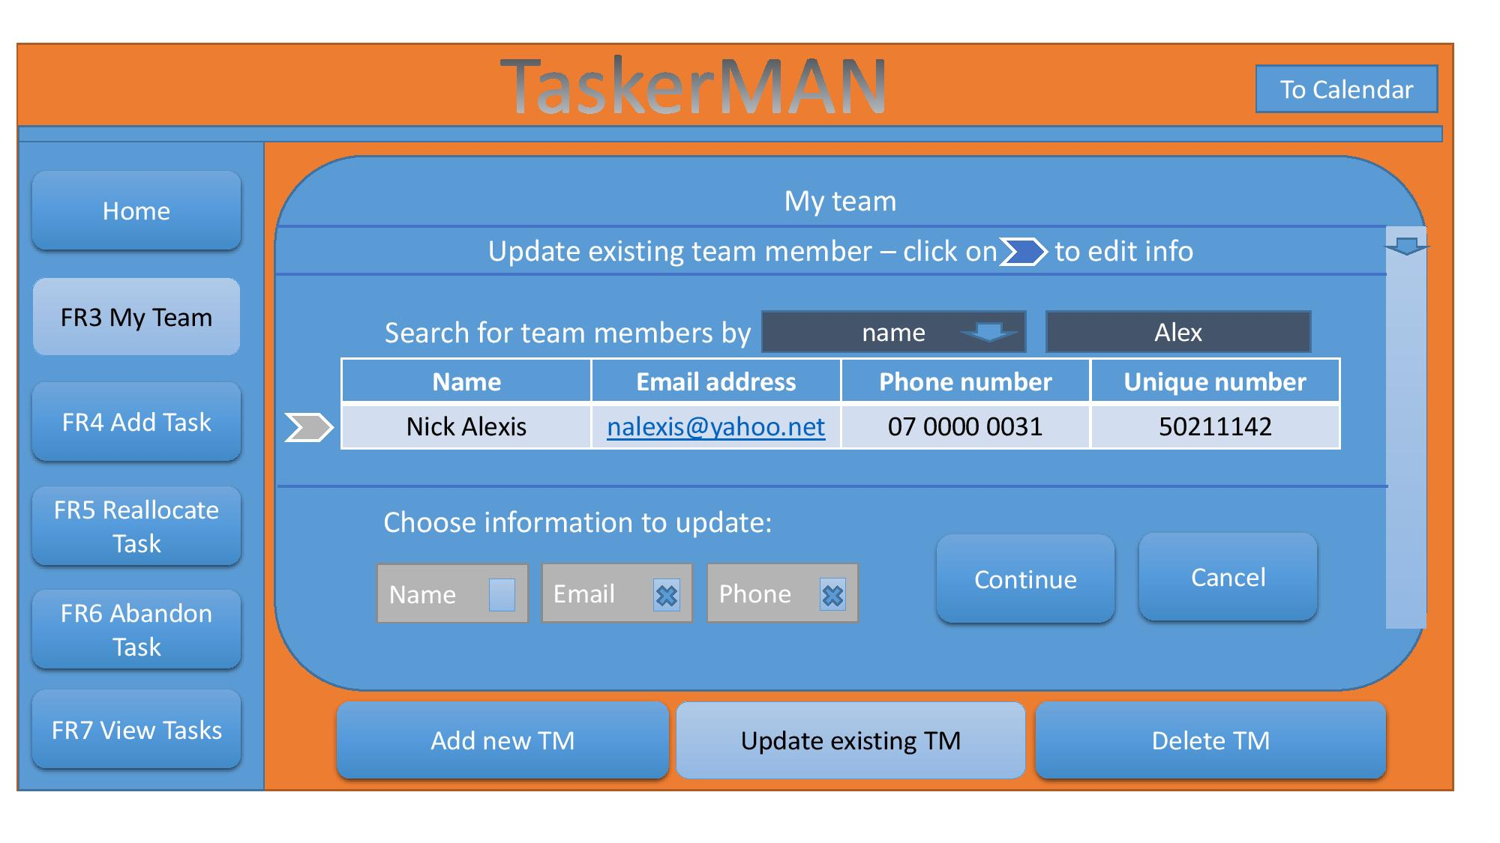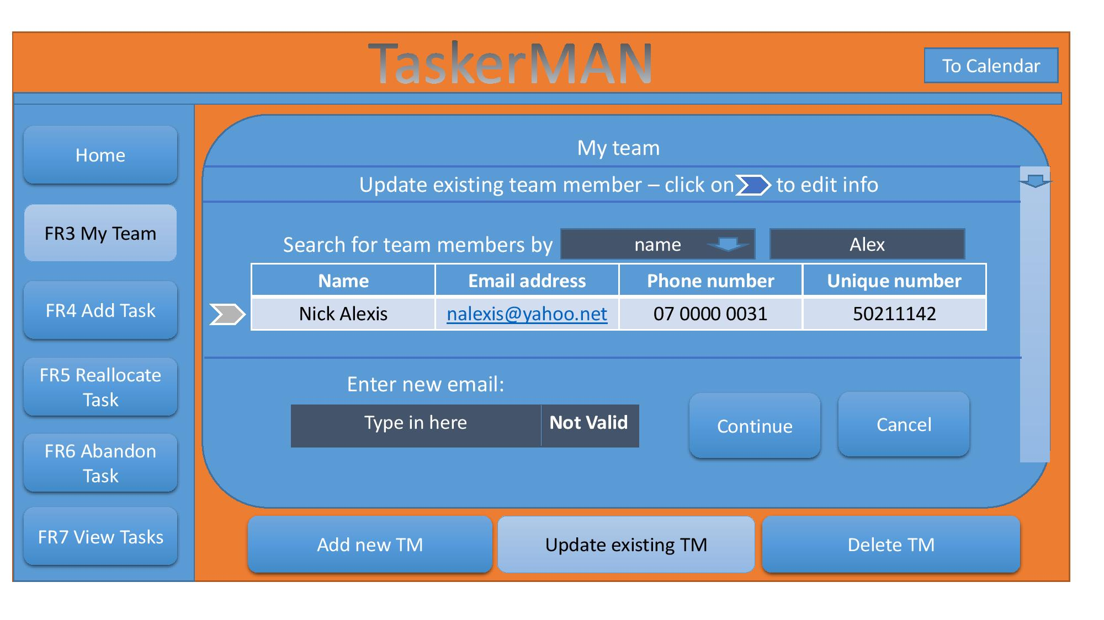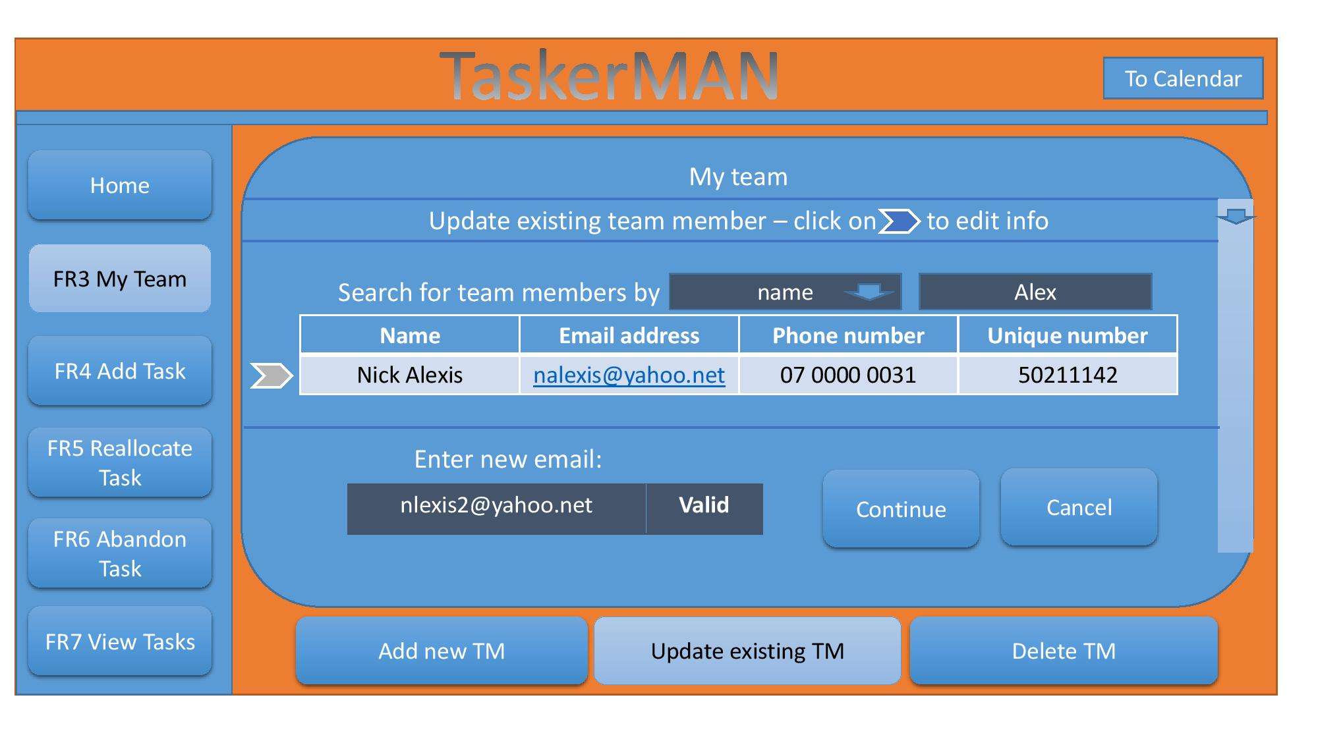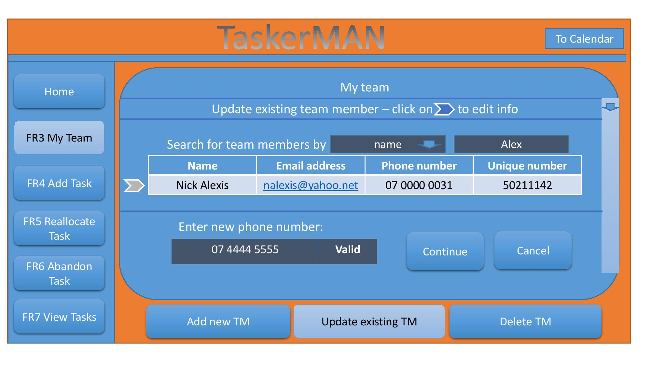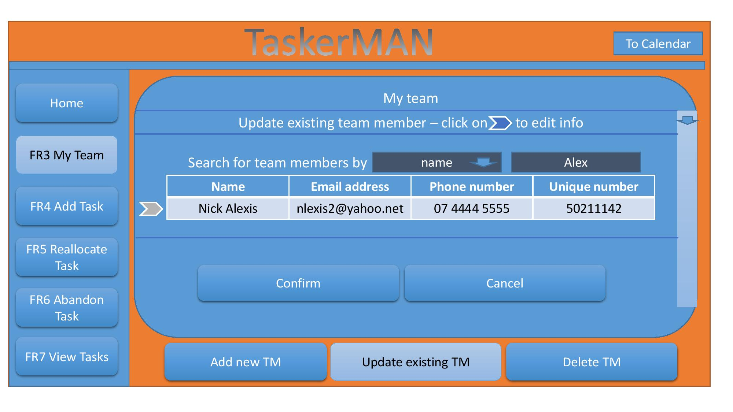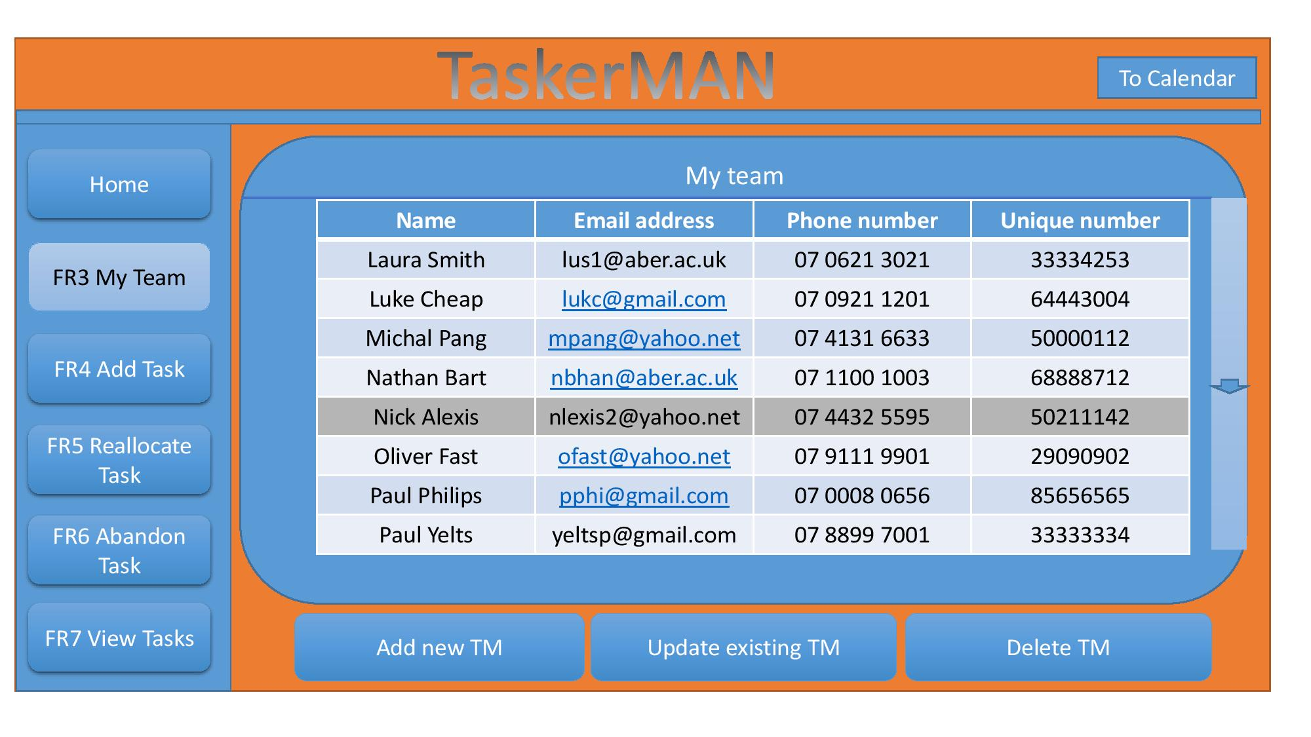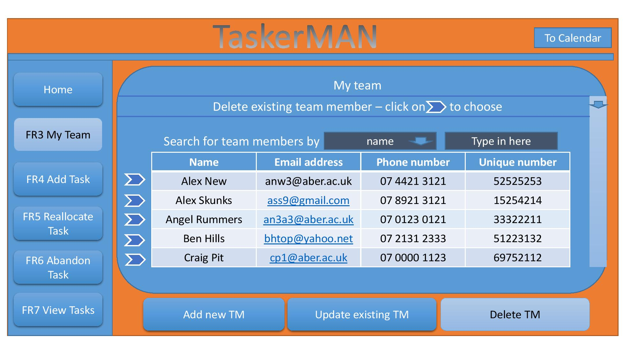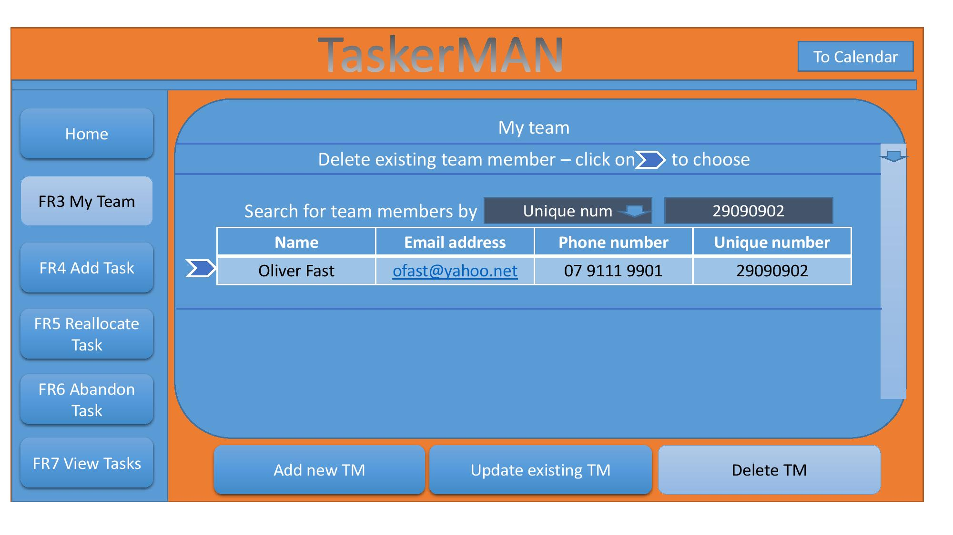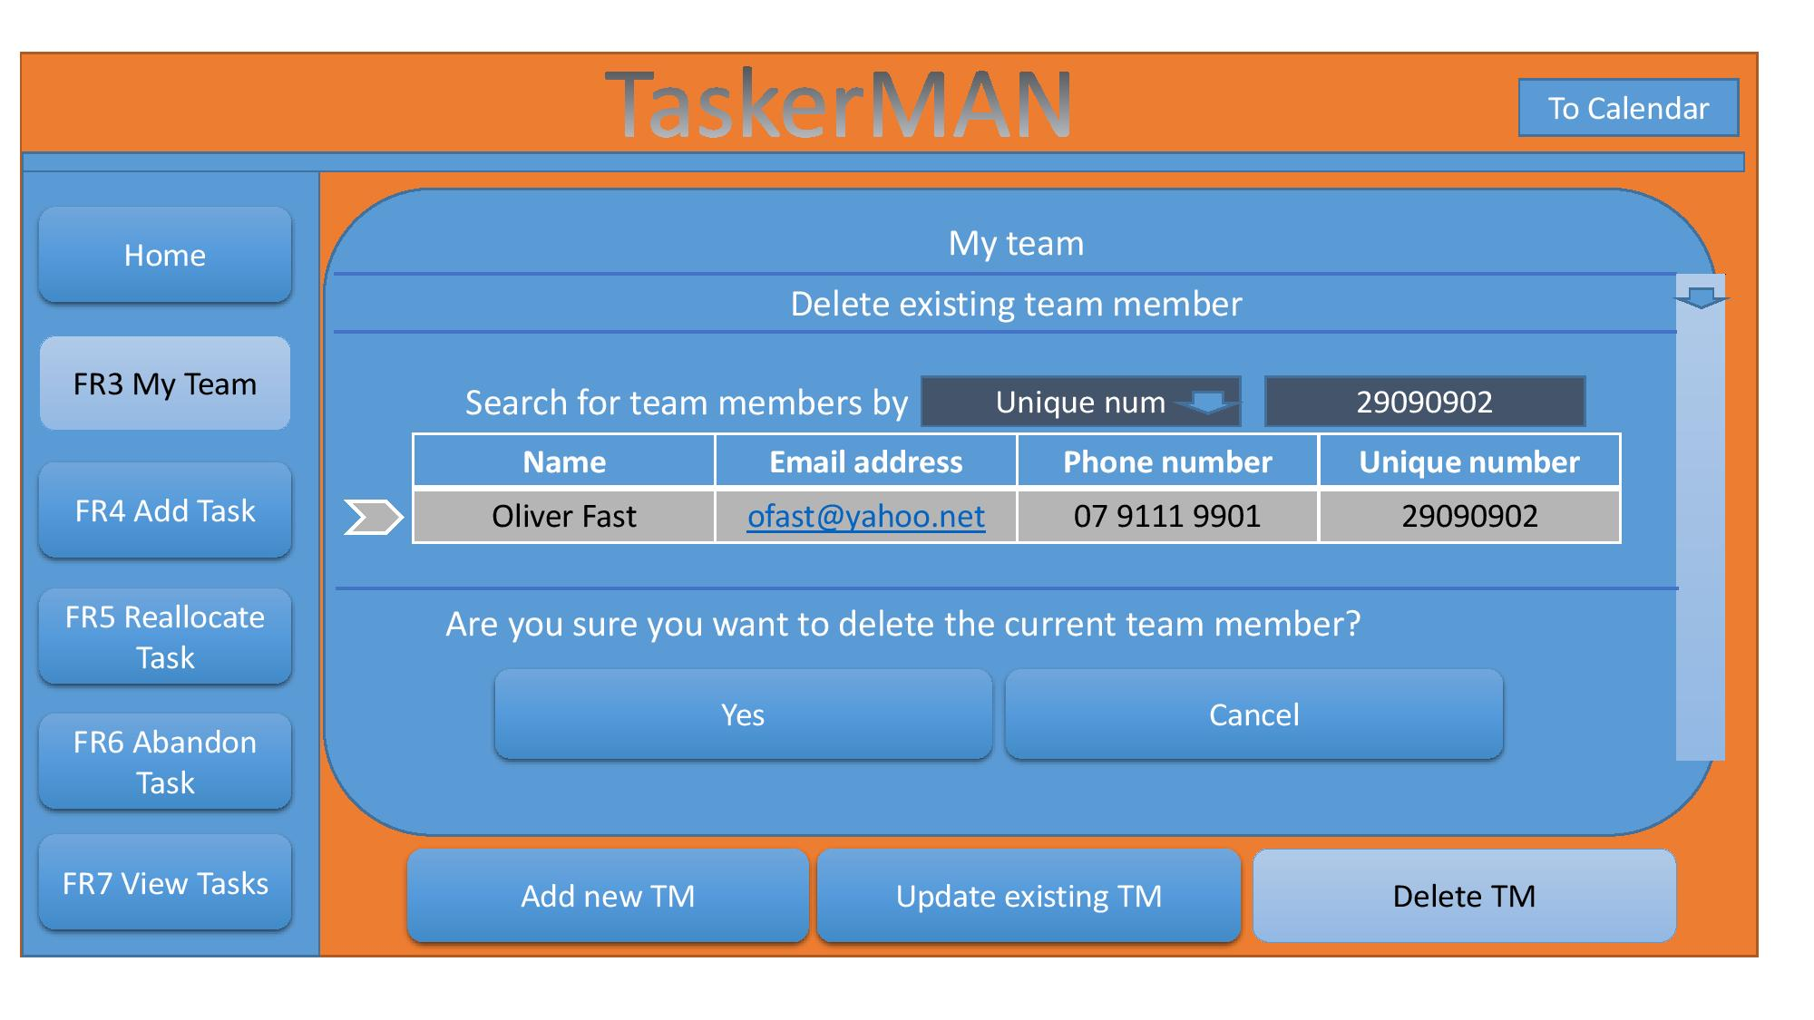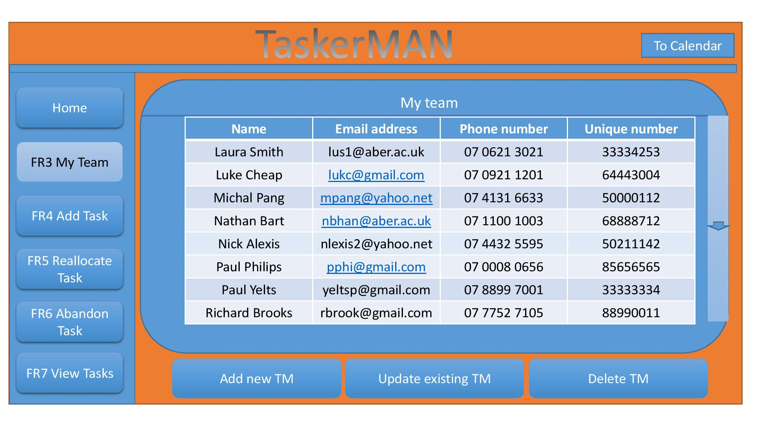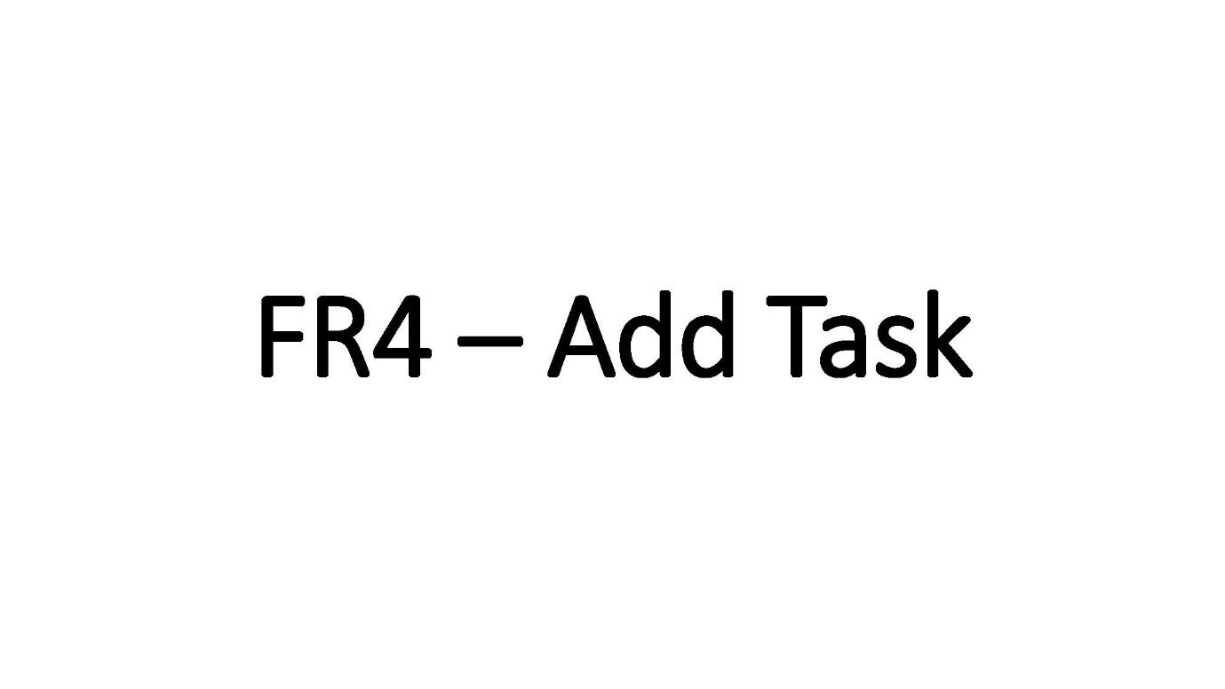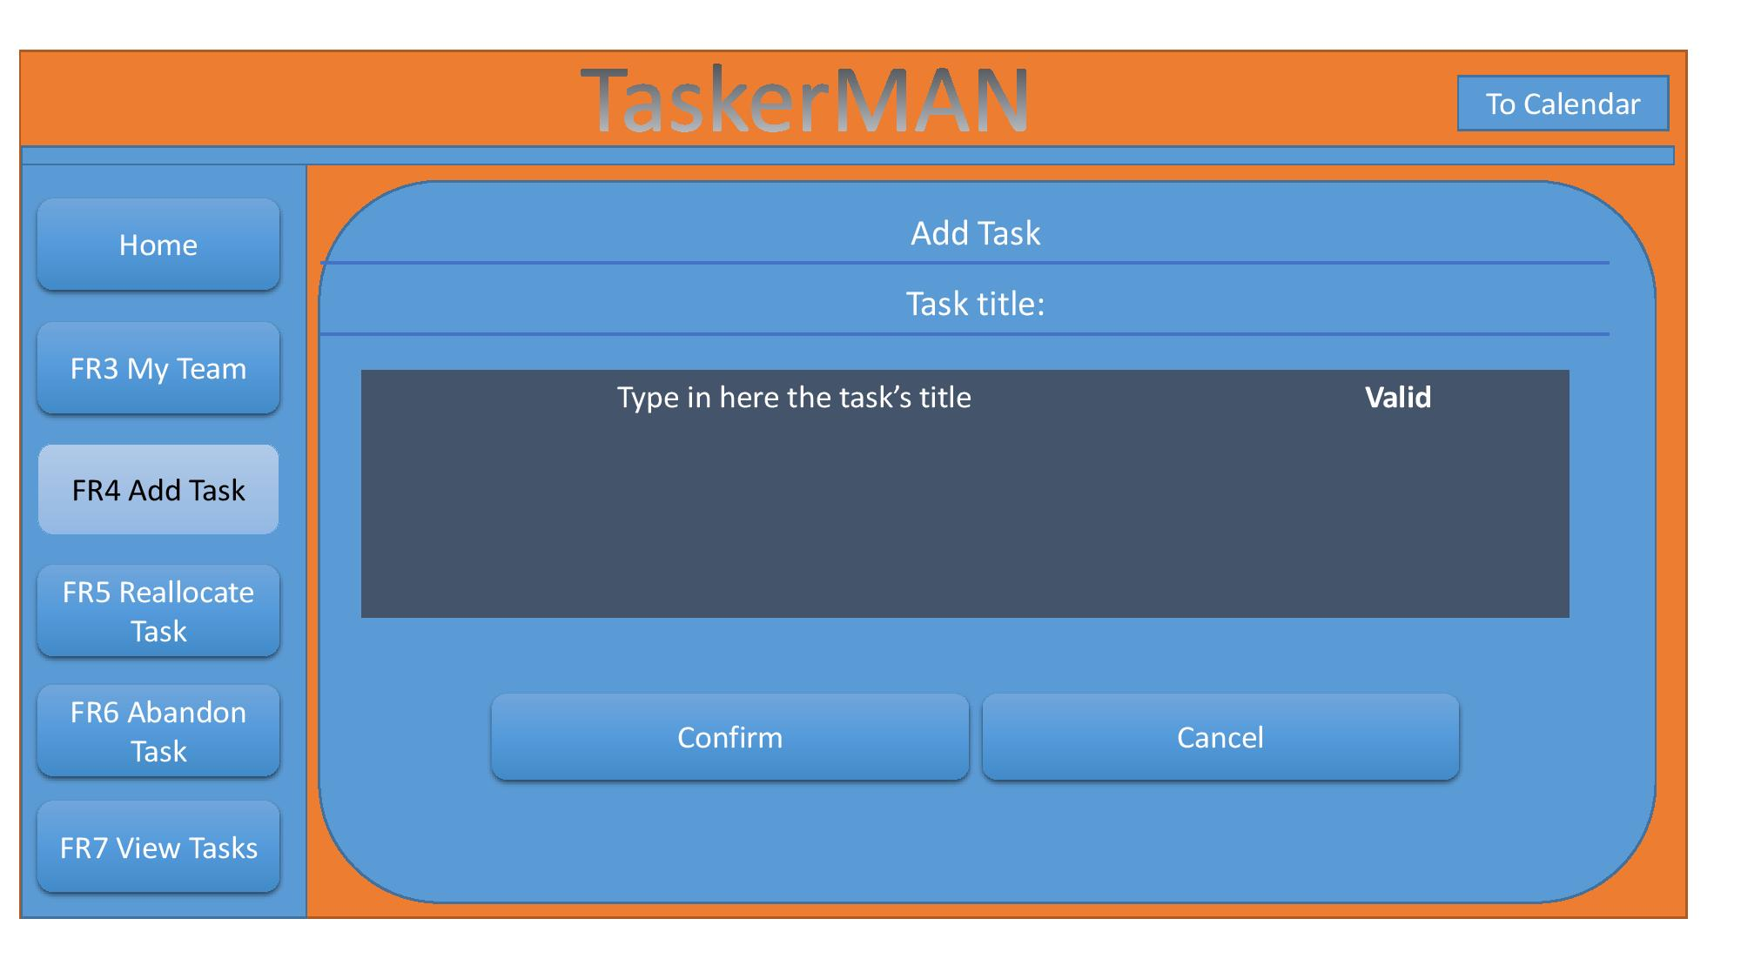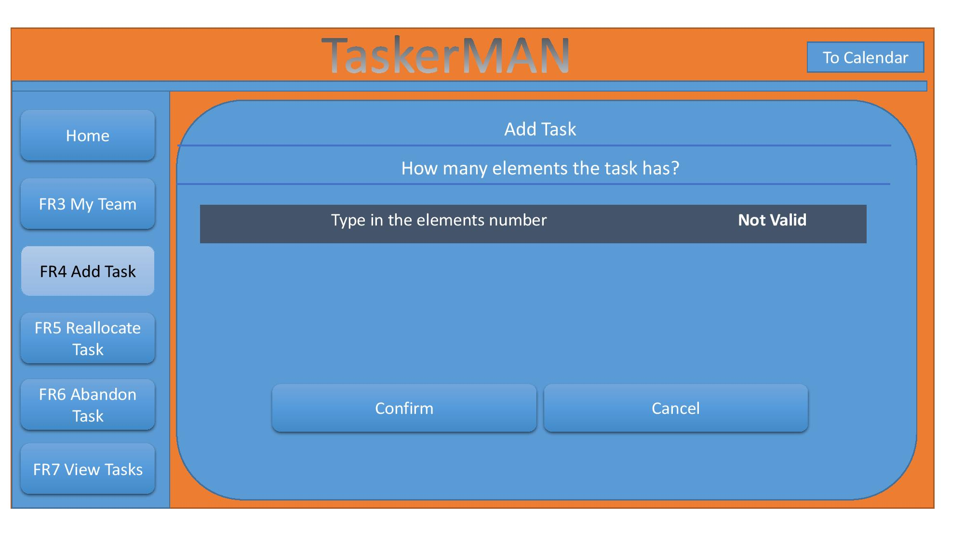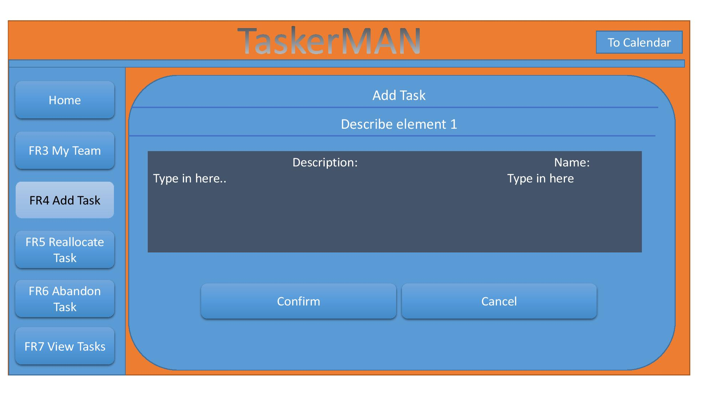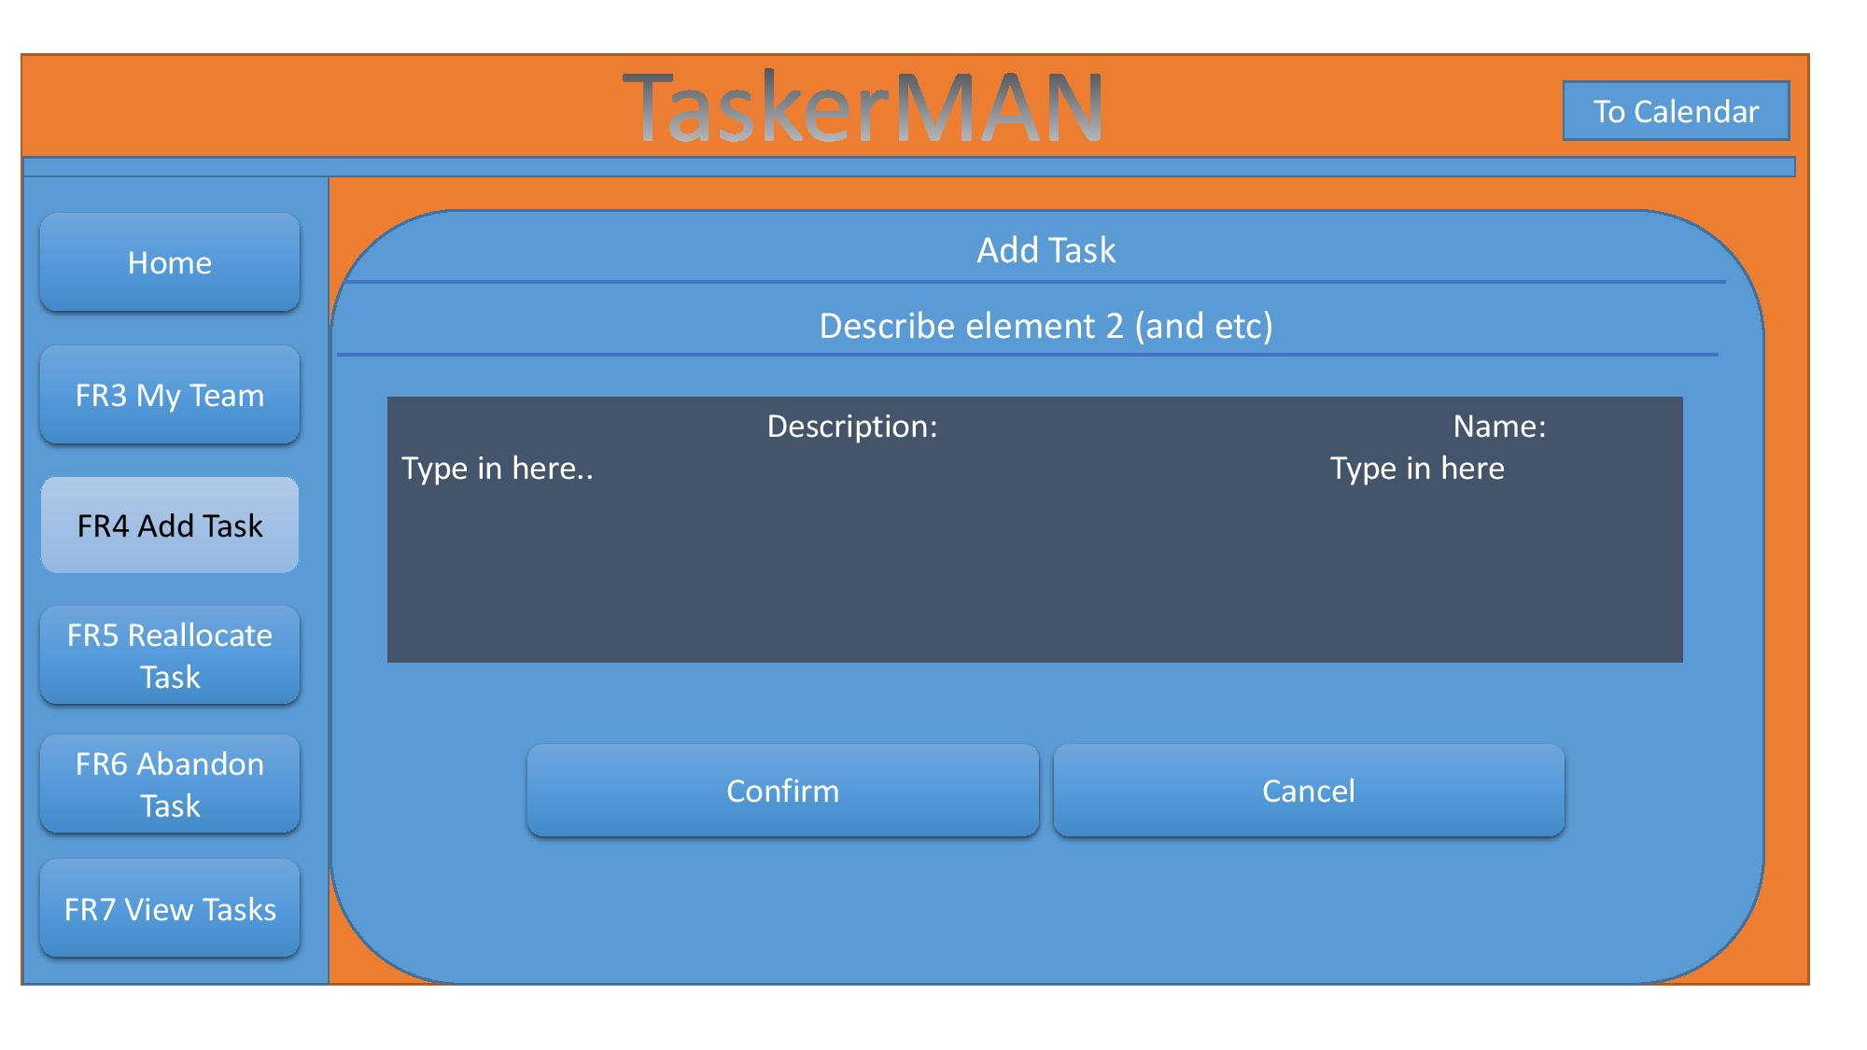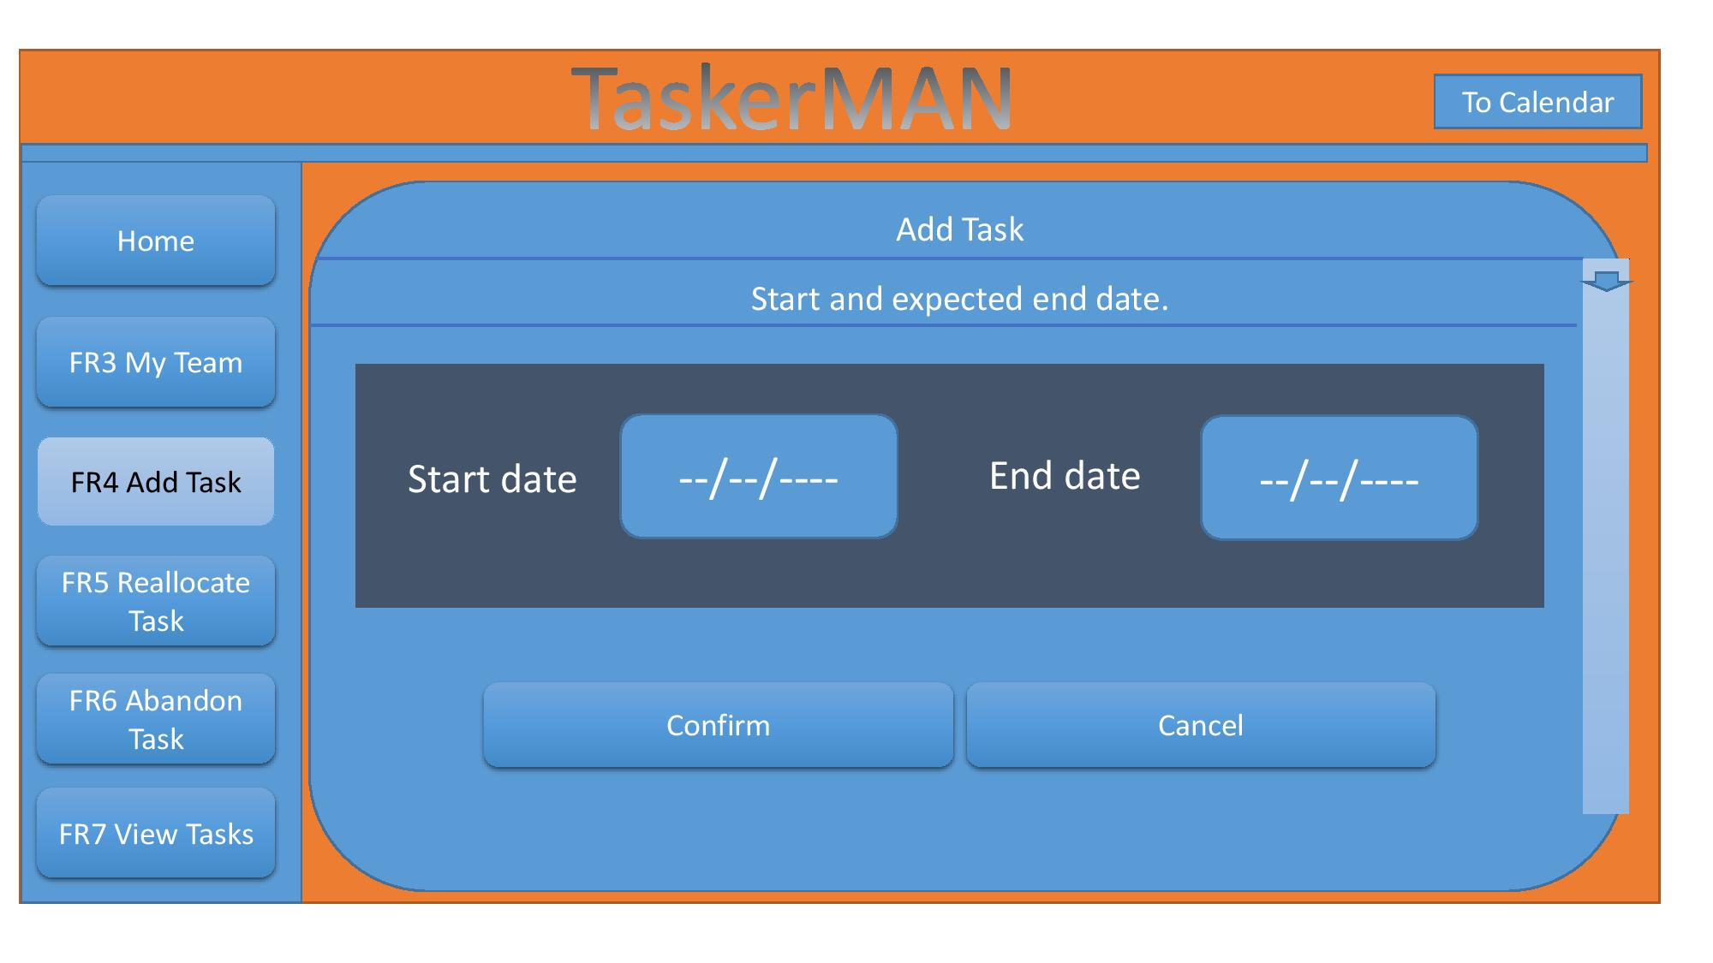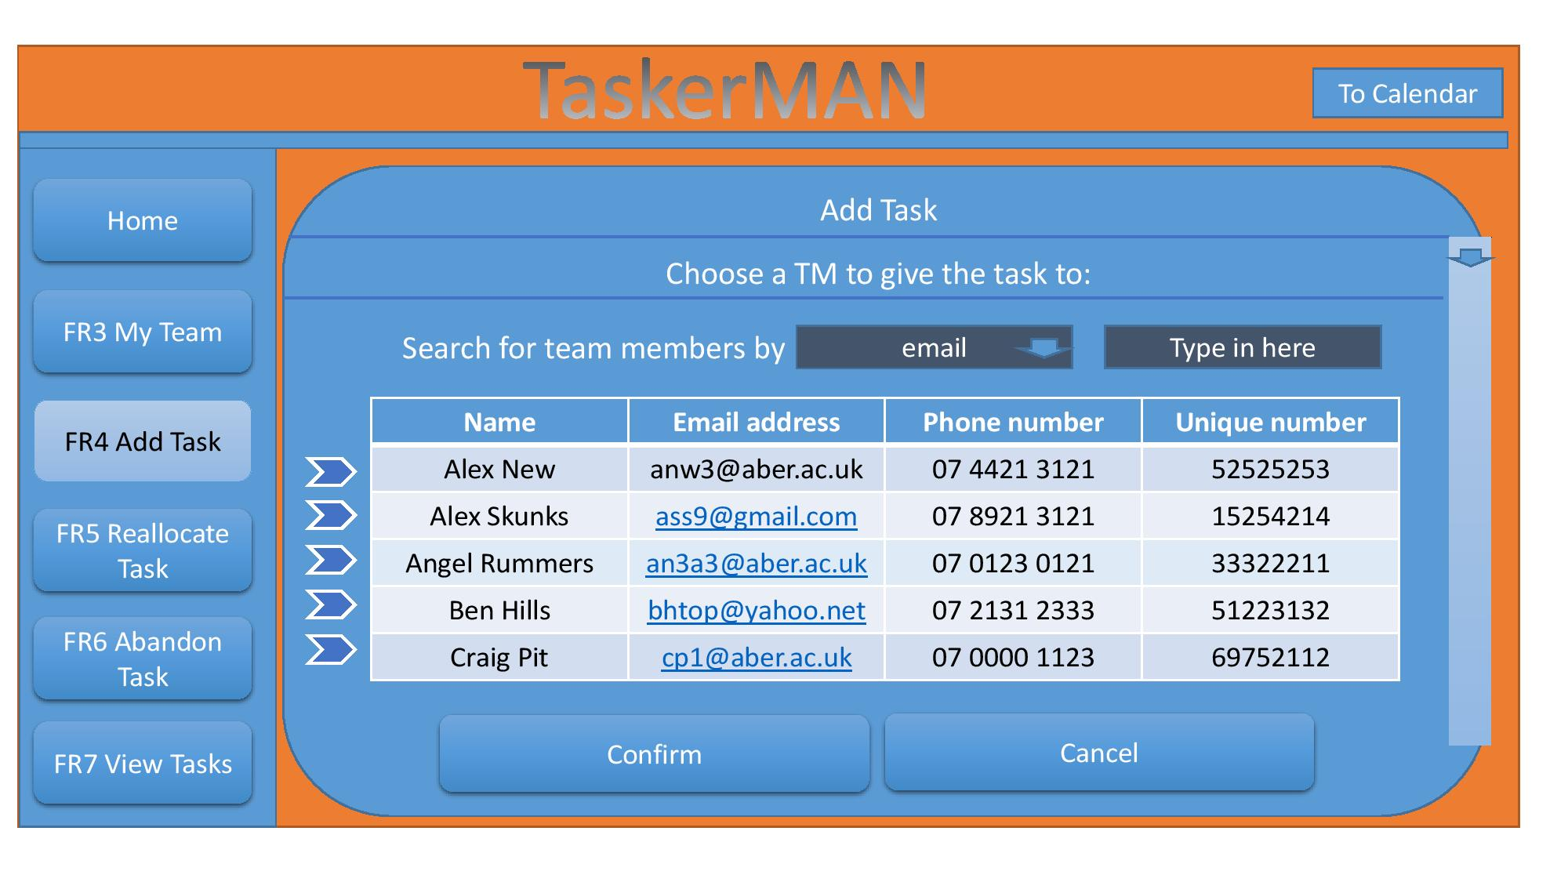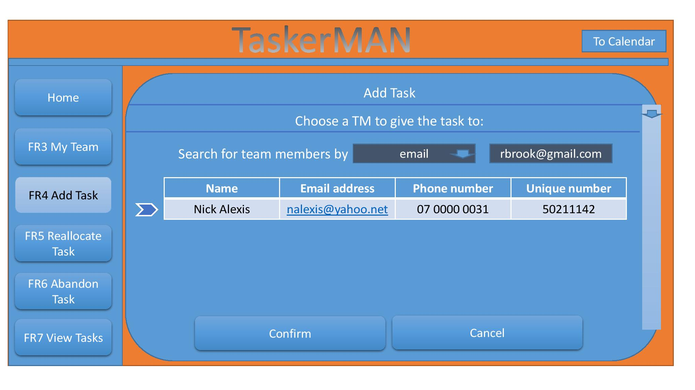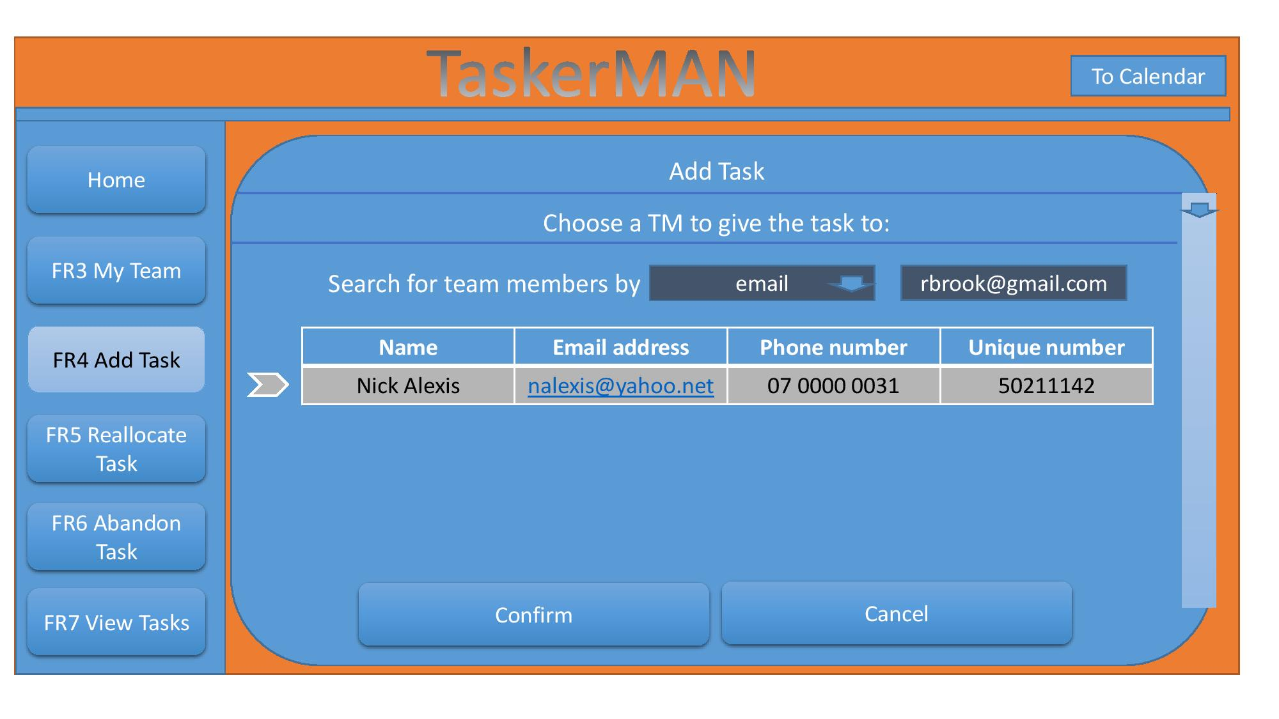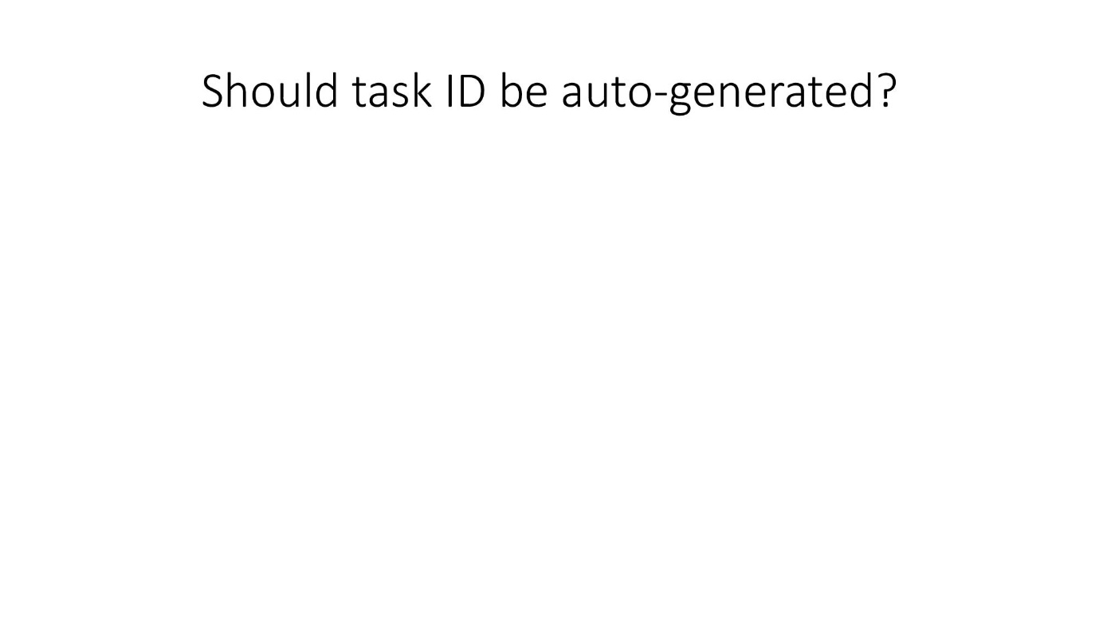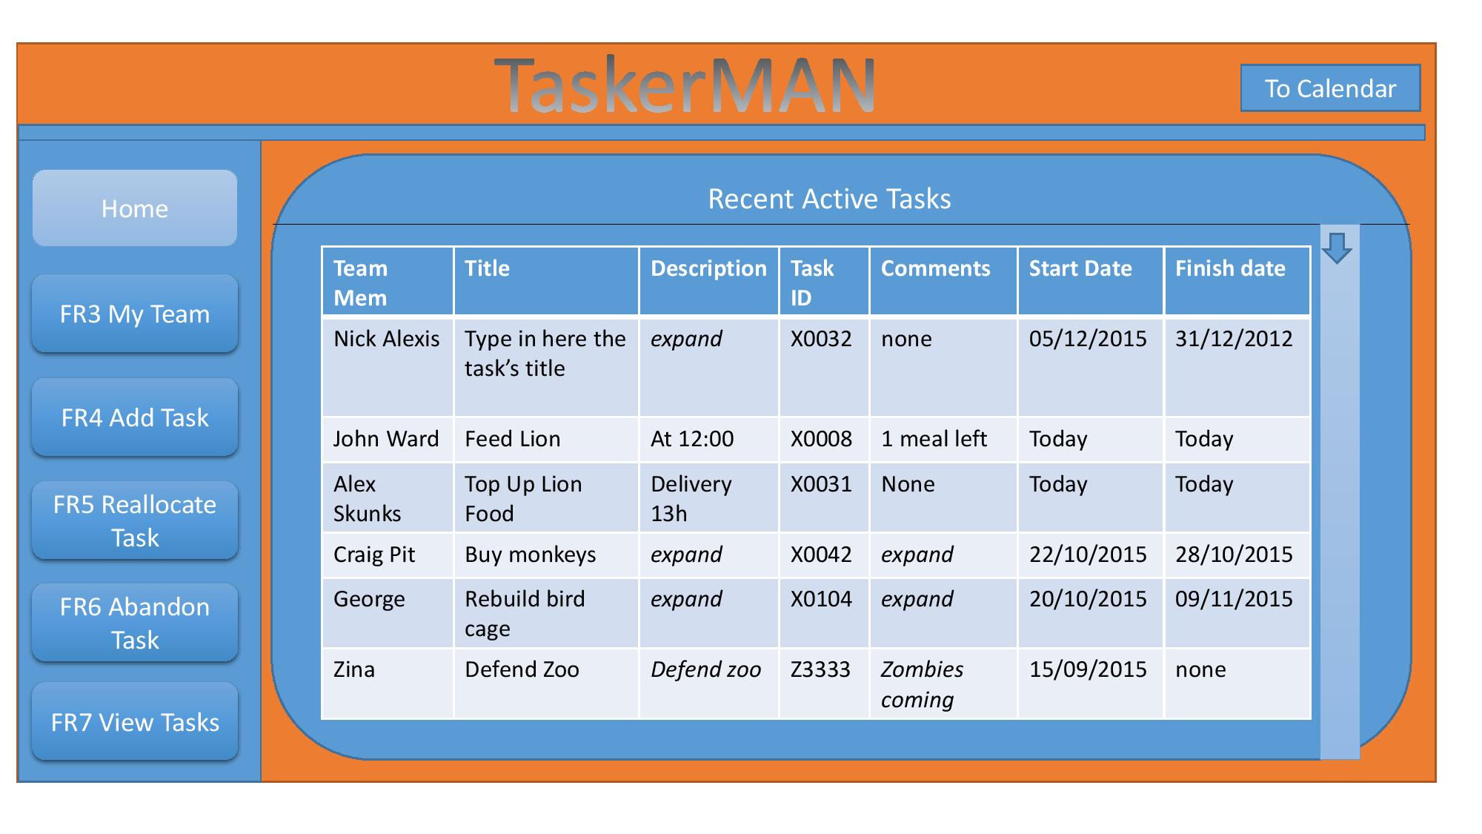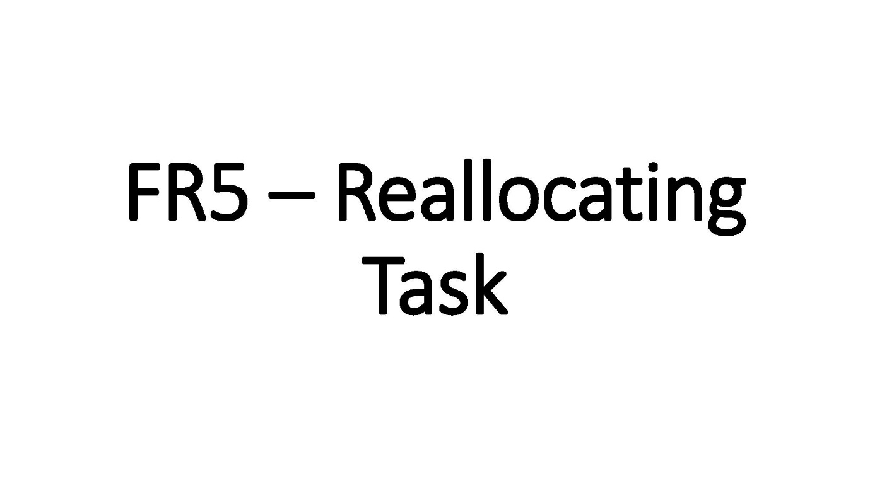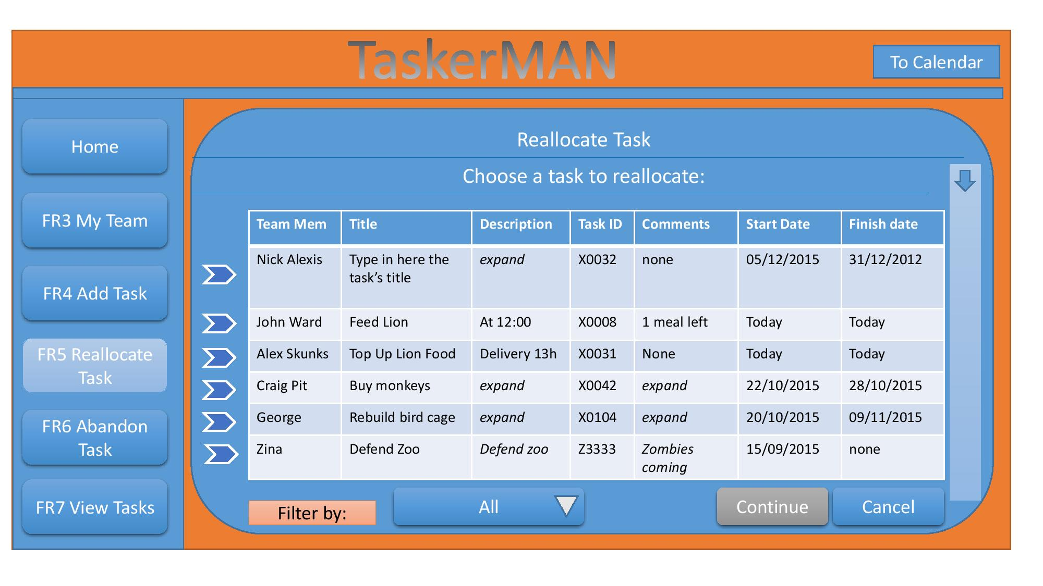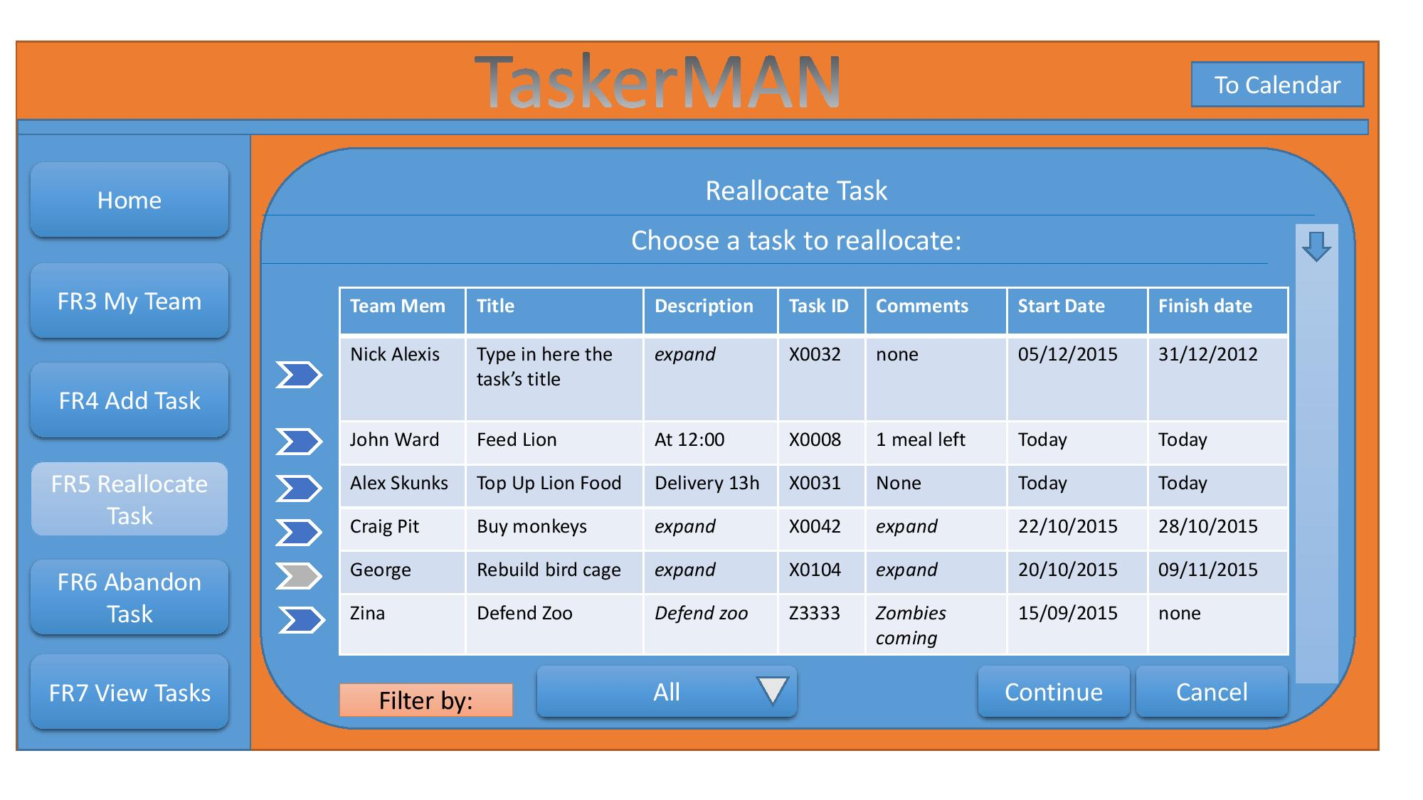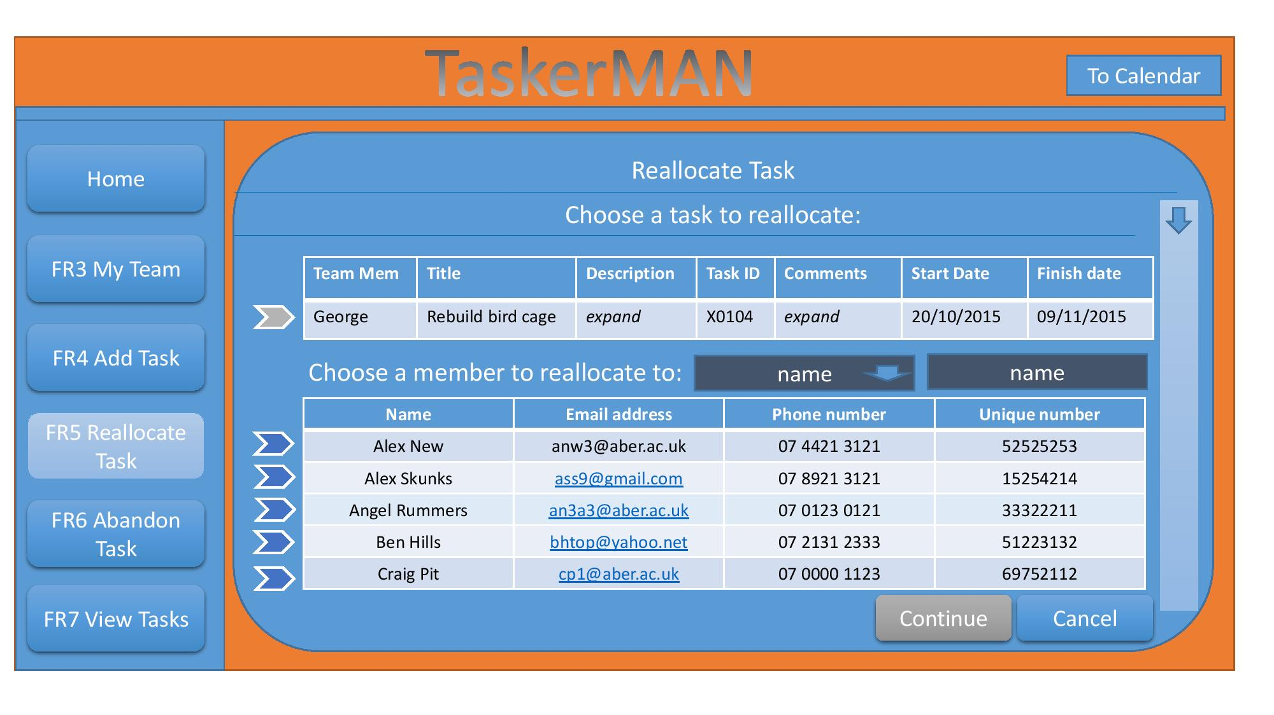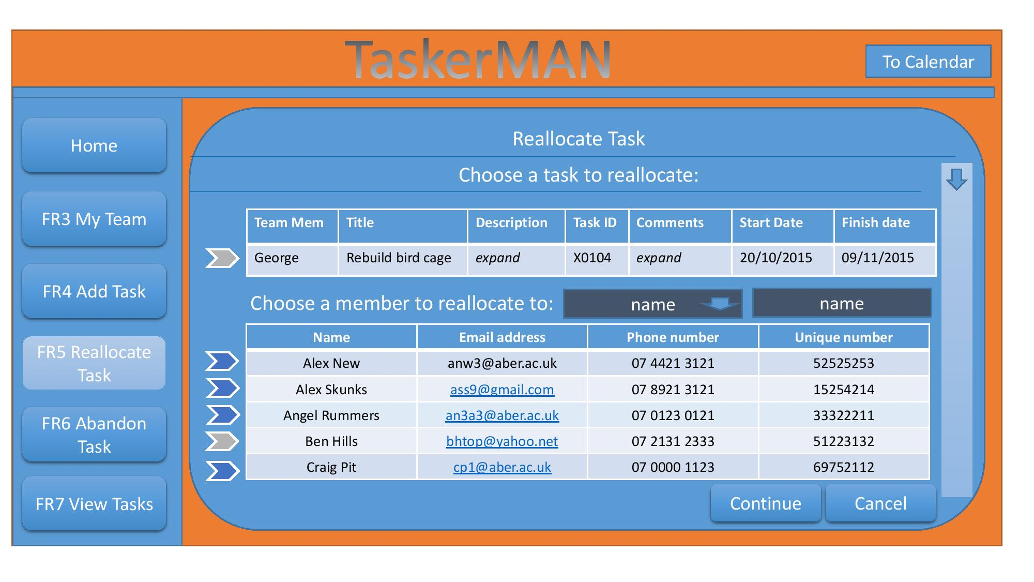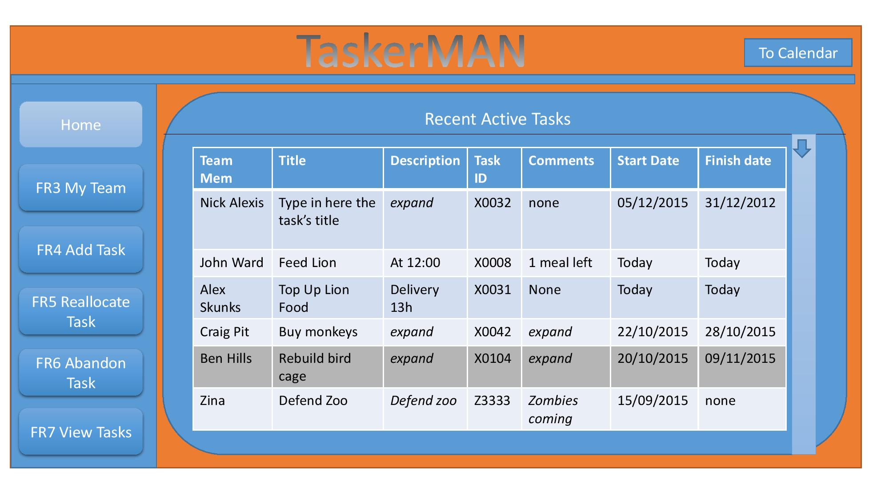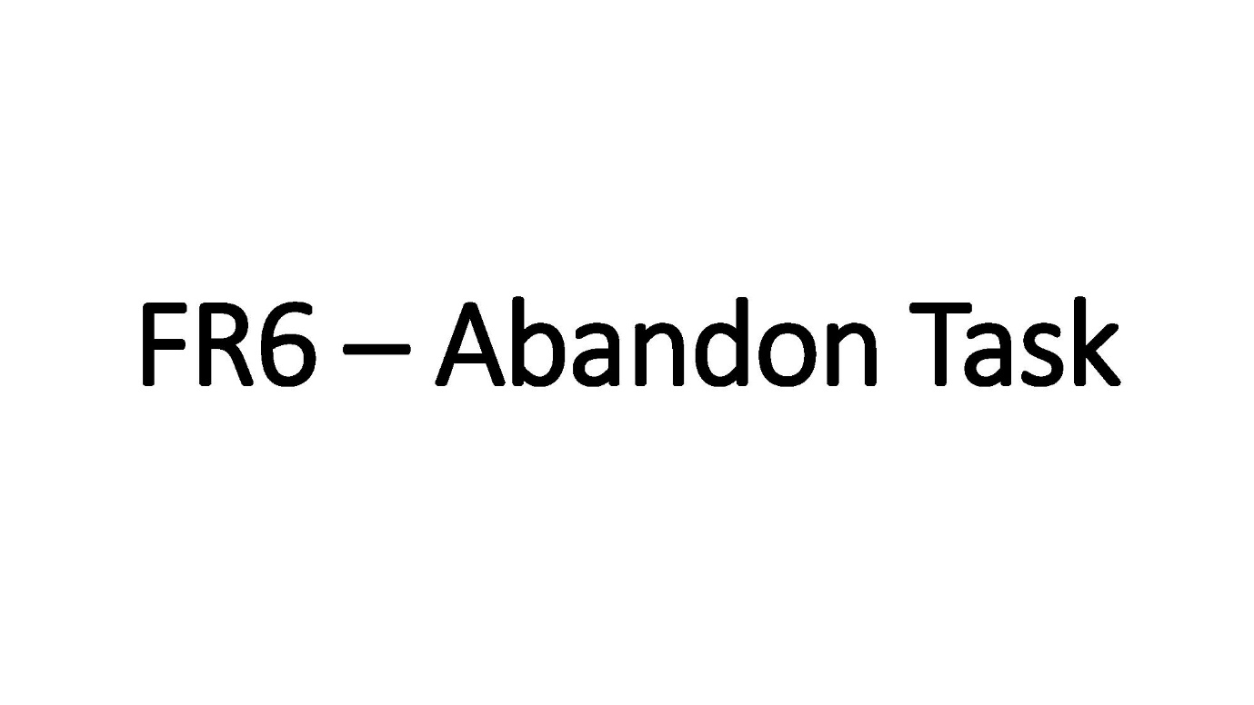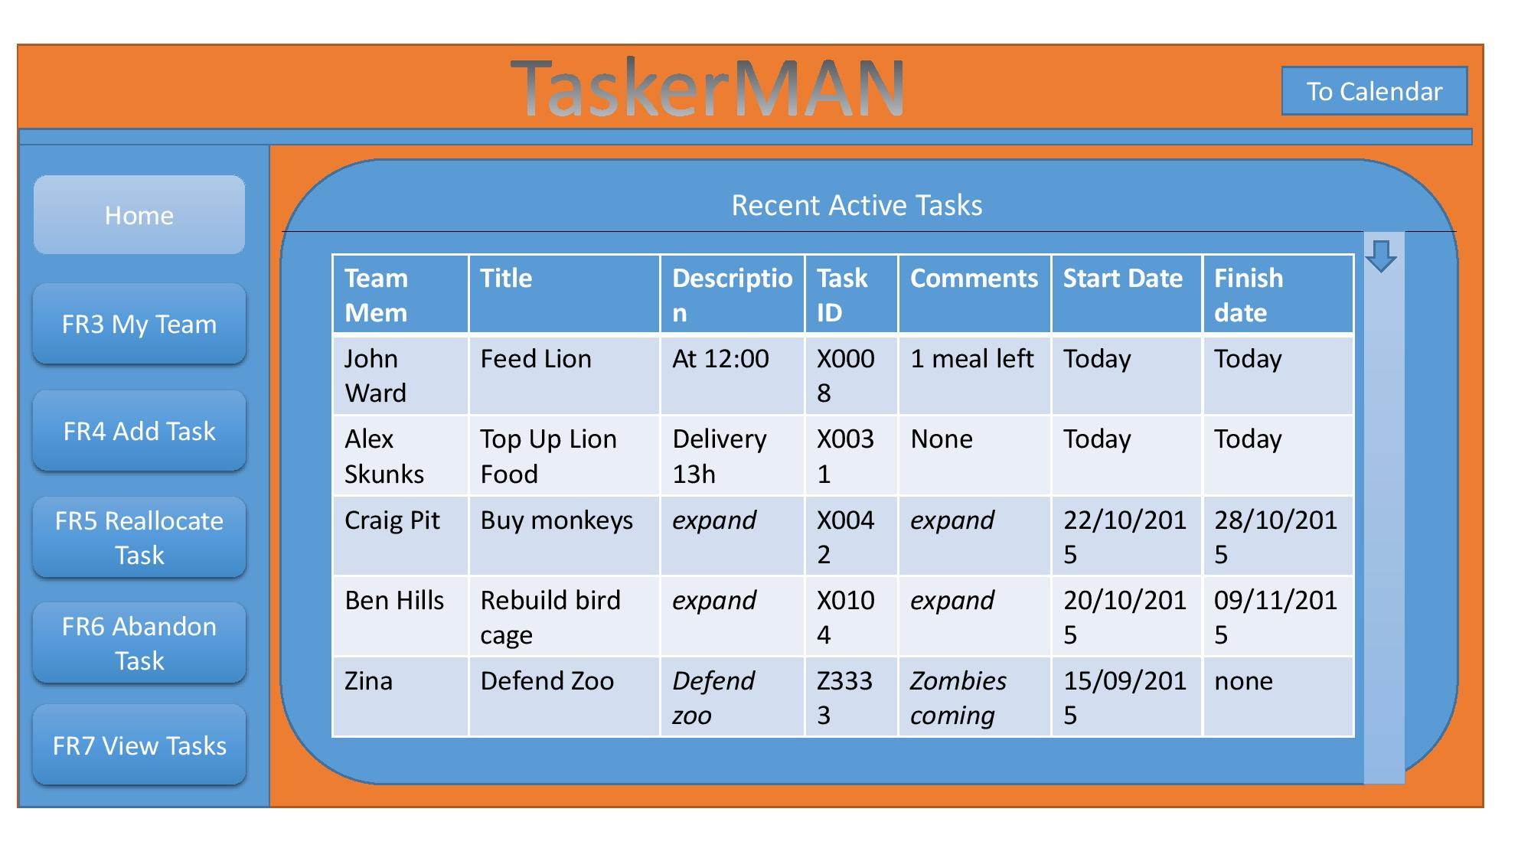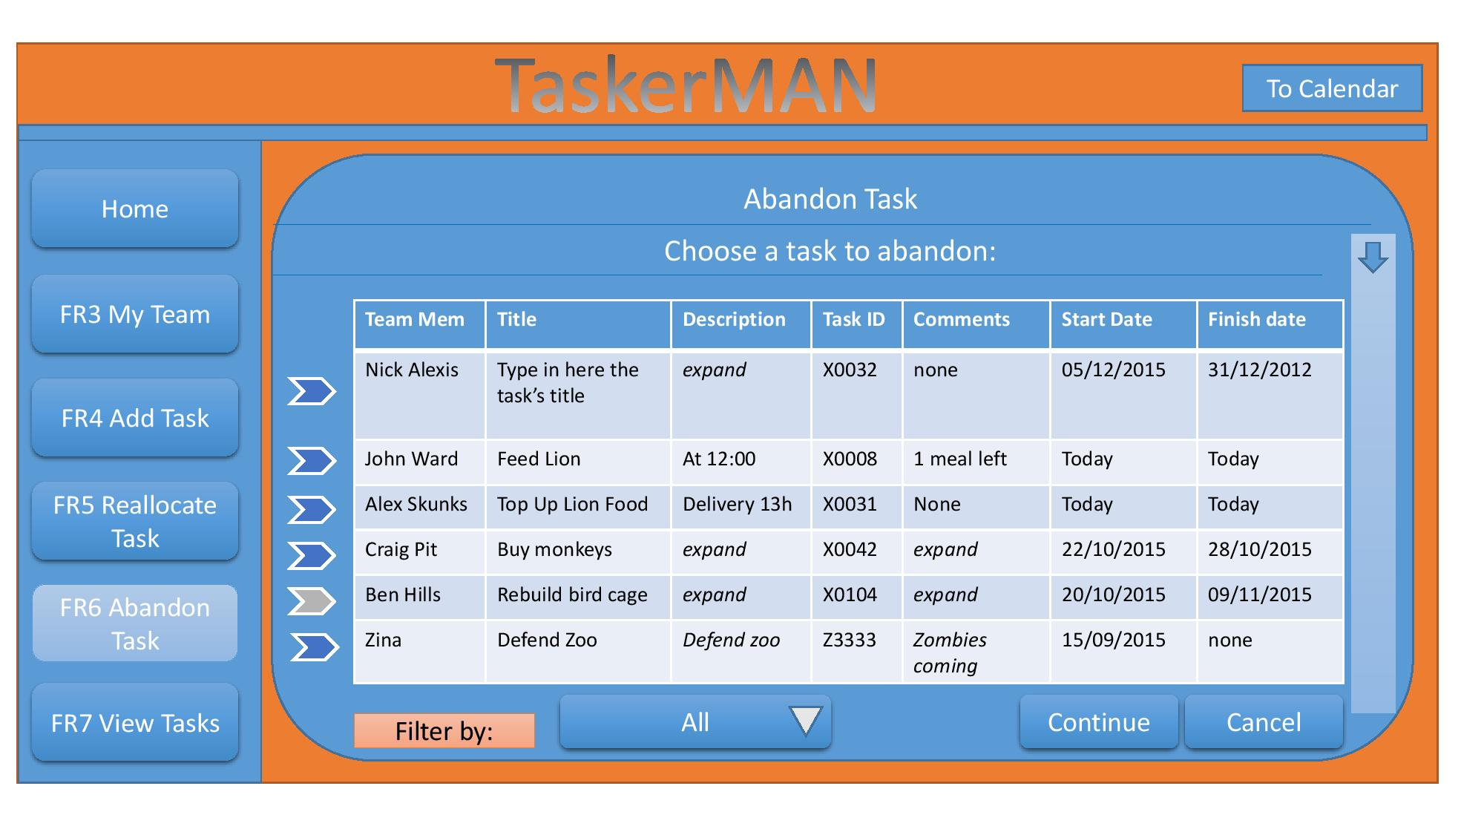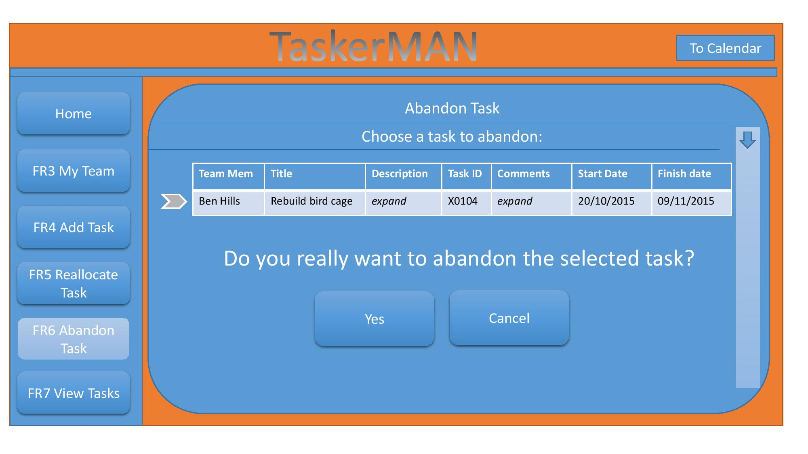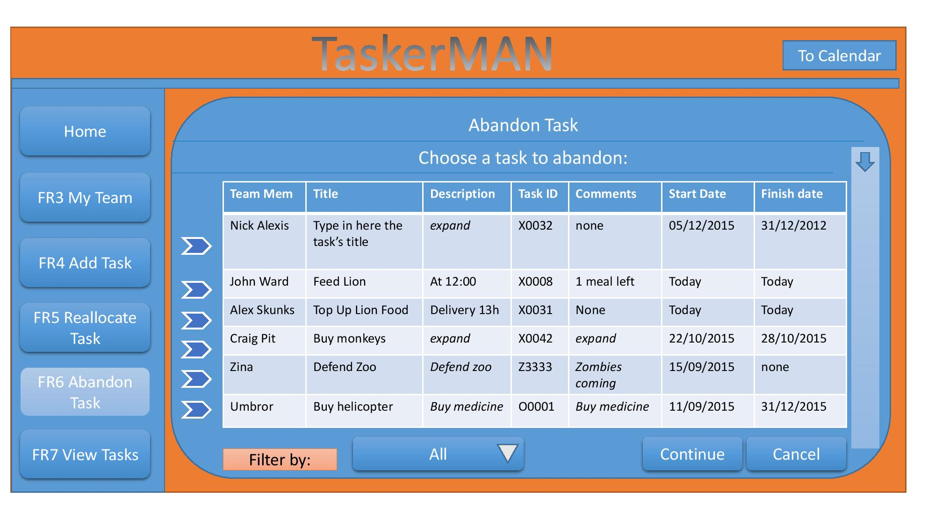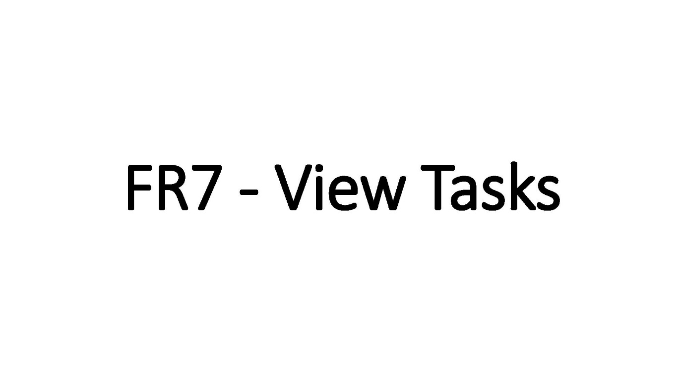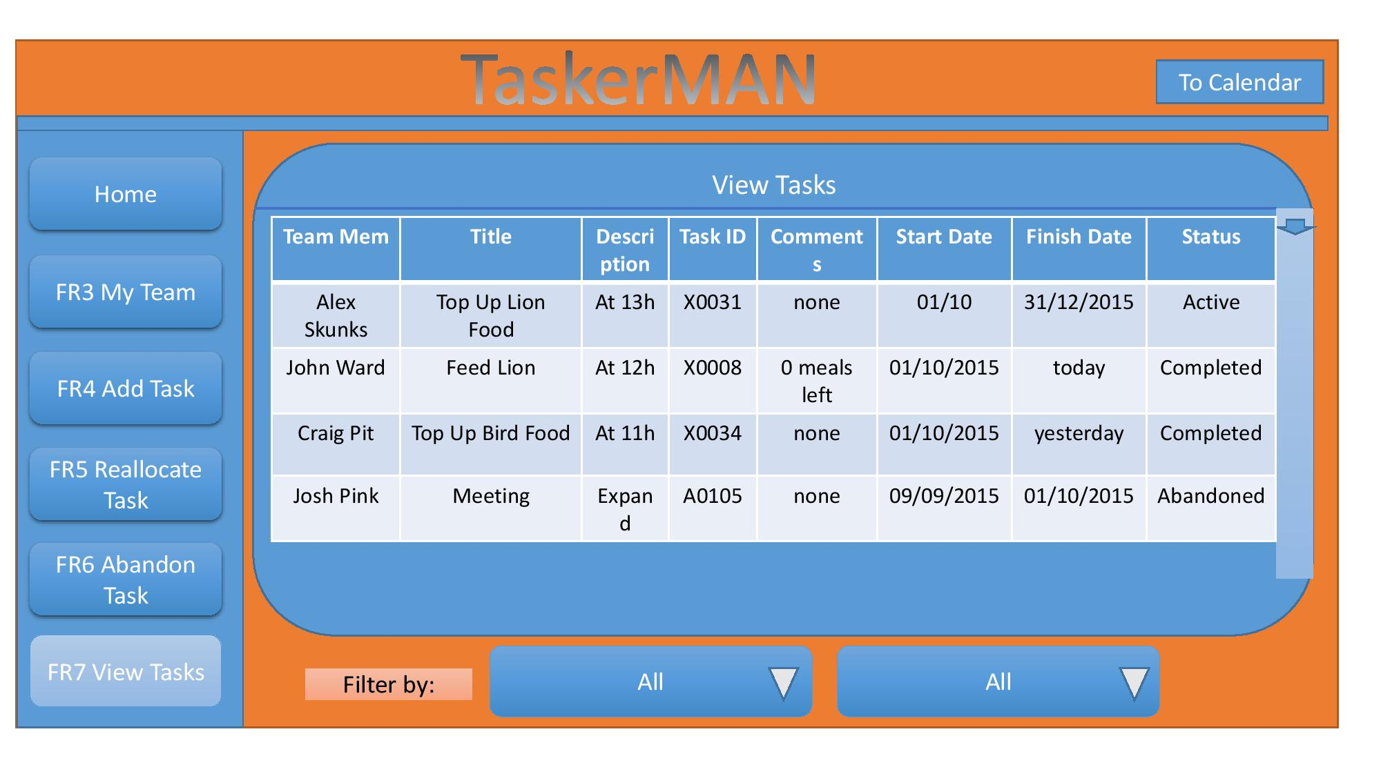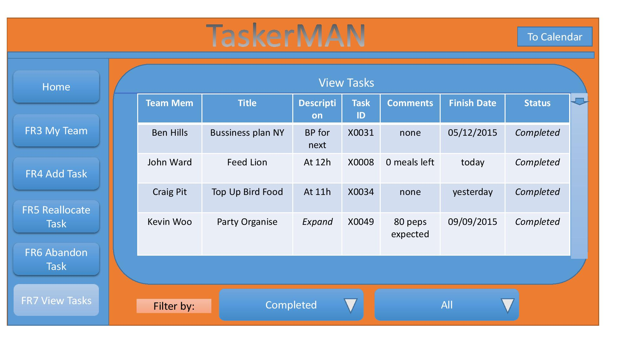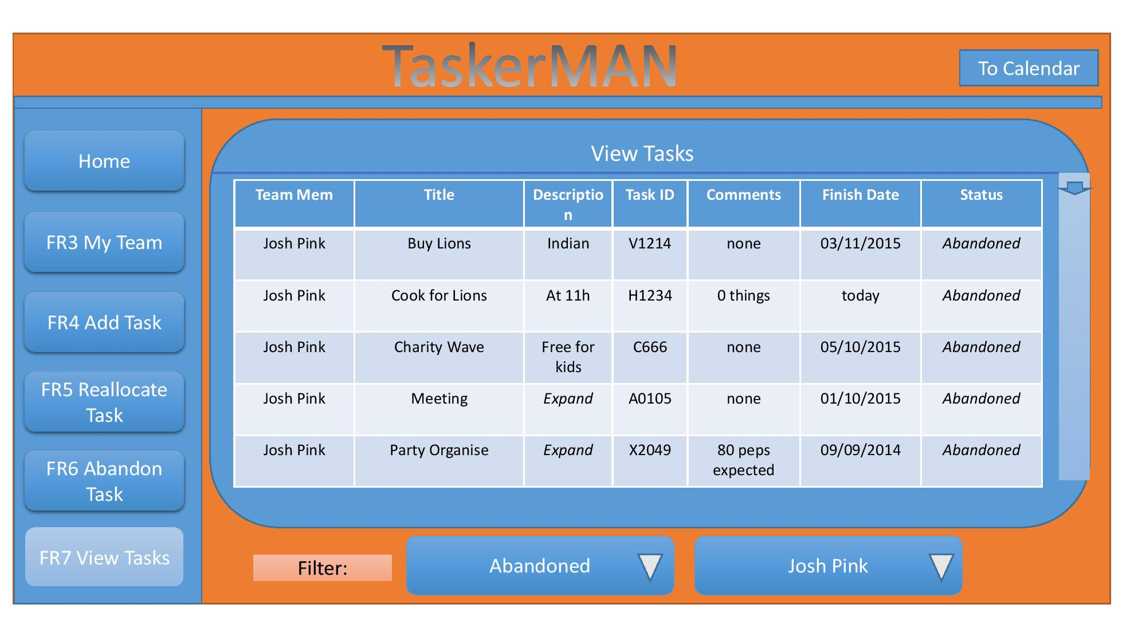

7.2 Appendix B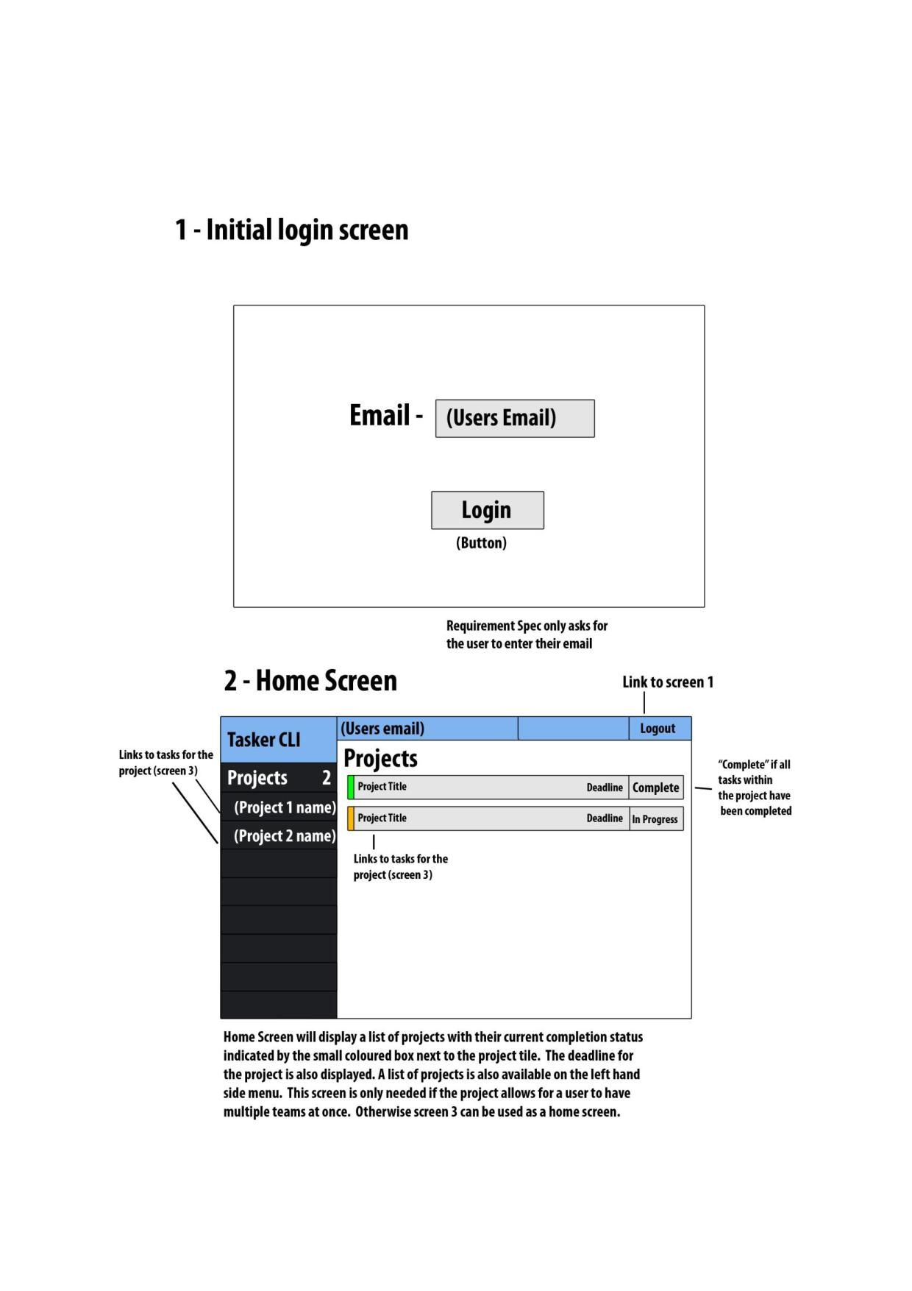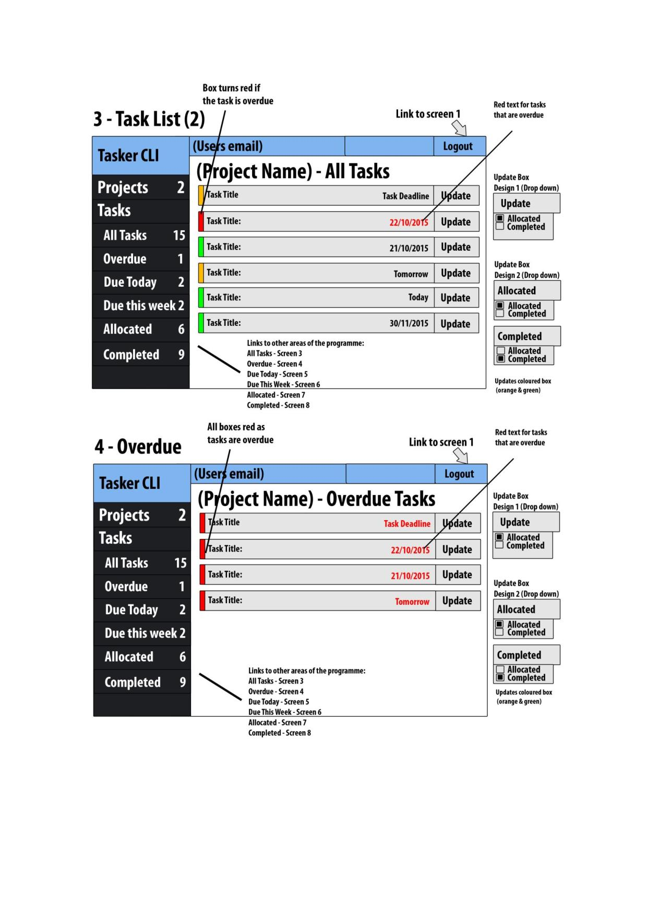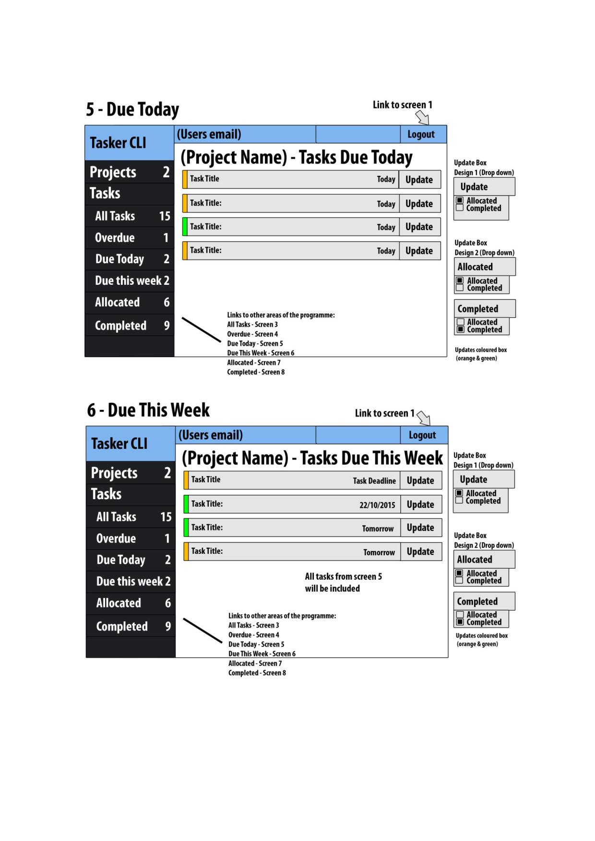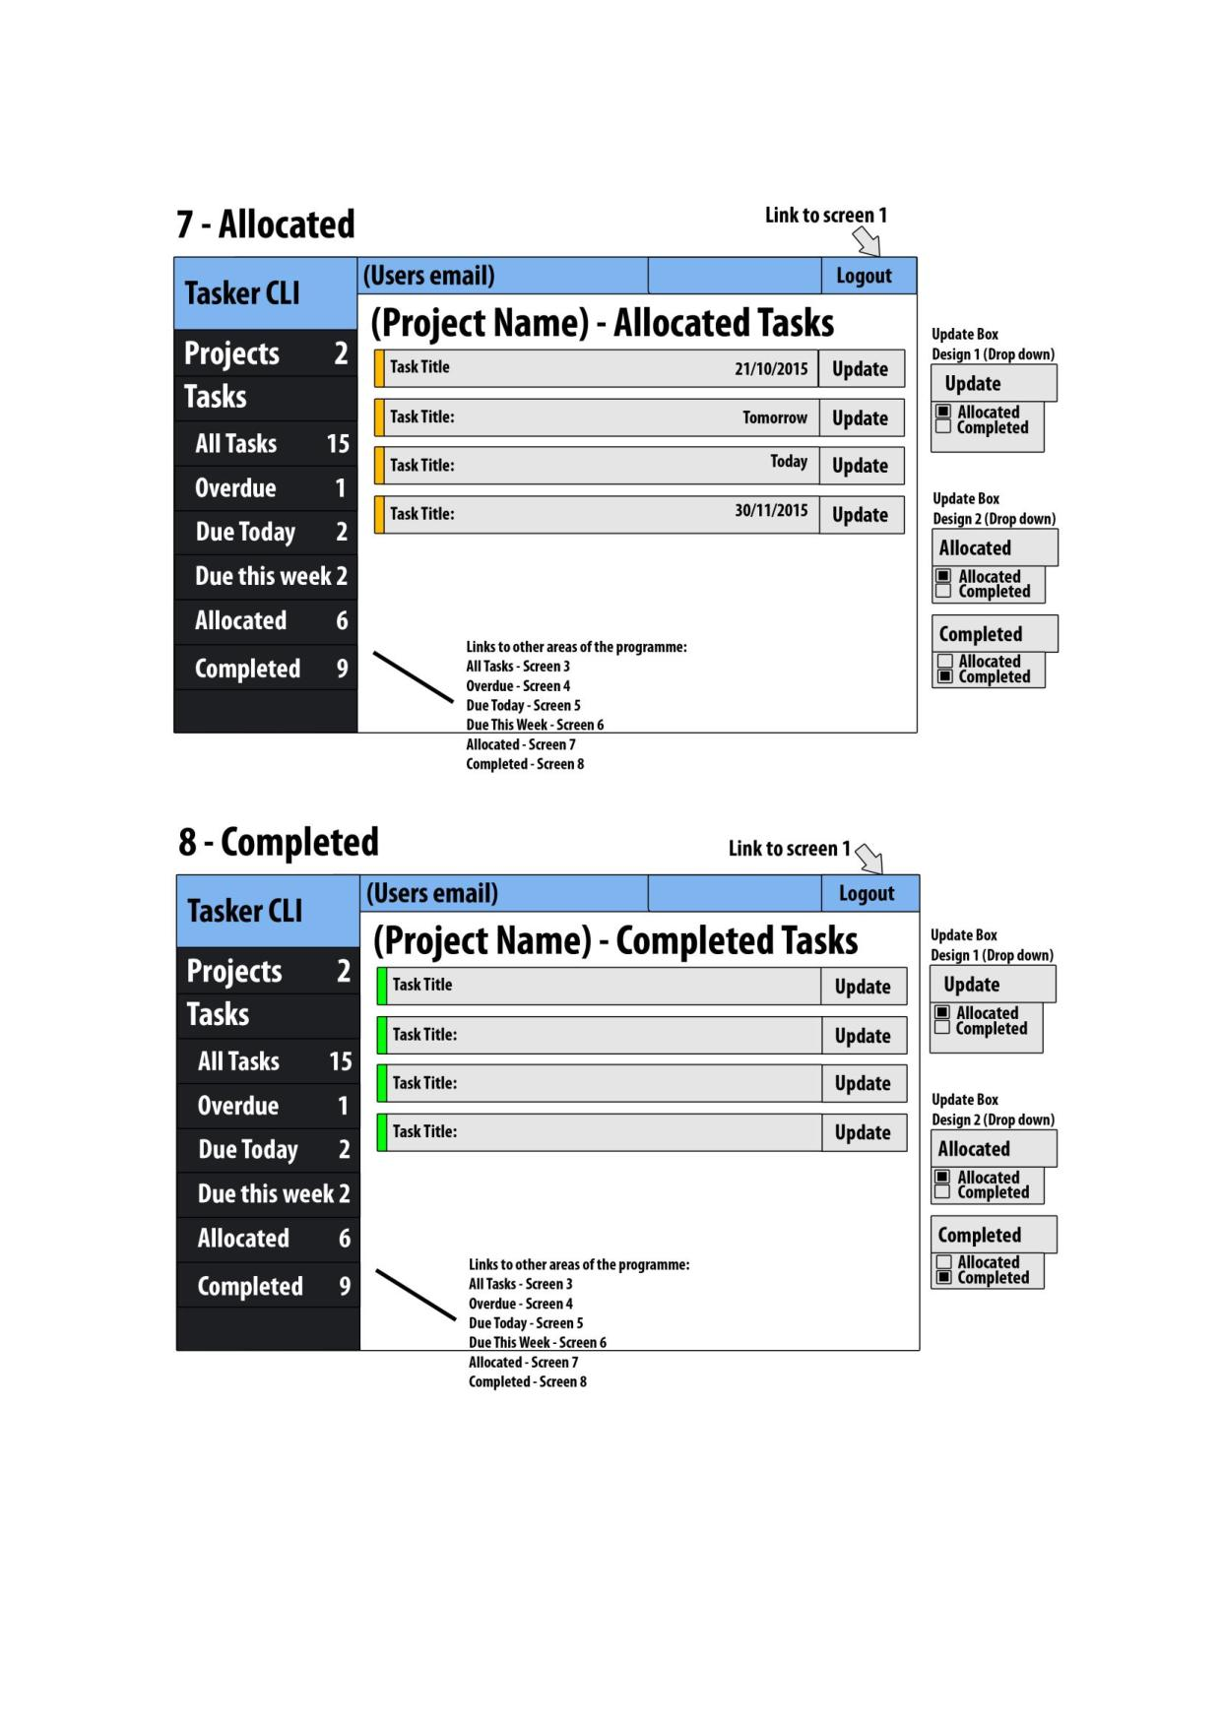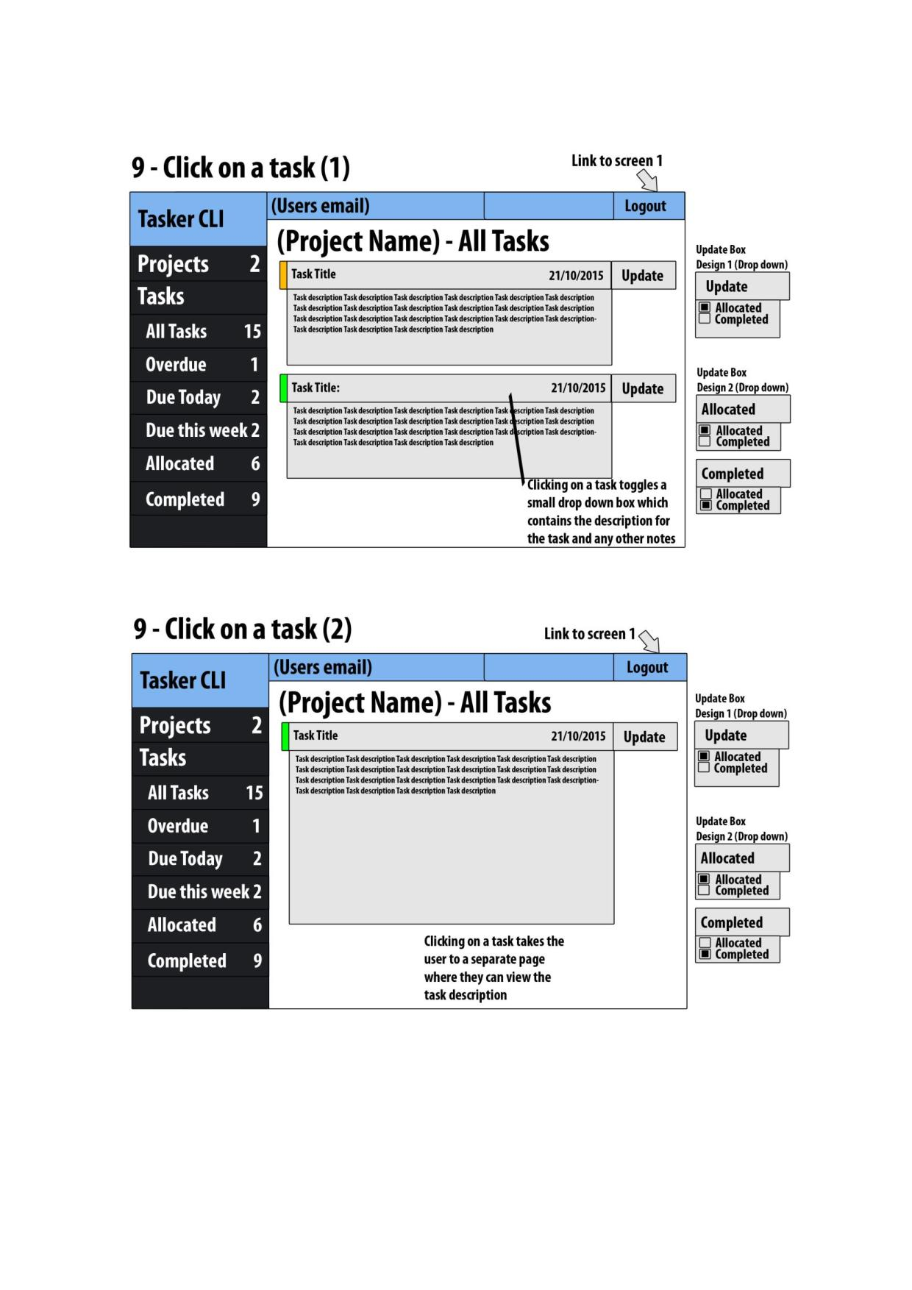

# 8 References

[1] Software Engineering Group Projects: Design Specification Standards.

# 9 Document History

|  |  |  |  |  |
| --- | --- | --- | --- | --- |
| Version | CCF No. | Date | Changes made to document | Changed by |
| 1.0 | N/A | 26/10/2015 | Document created by Alexander Webb (ajw21) | AJW21 |
| 1.1 | N/A | 27/10/2015 | Grammar corrections by Frederik Kranich (frk2) | FRK2 |
| 1.2 | N/A | 28/10/2015 | Minor Grammar correction, updated the Document History (frk2) | FRK2 |